Daily Task on IAM
1. Create one IAM user and assign EC2 and S3 full access roles.
Step 1: Sign in to AWS Management Console
- Log in with your root account or an IAM admin user.
- Navigate to IAM (Identity and Access Management) service.
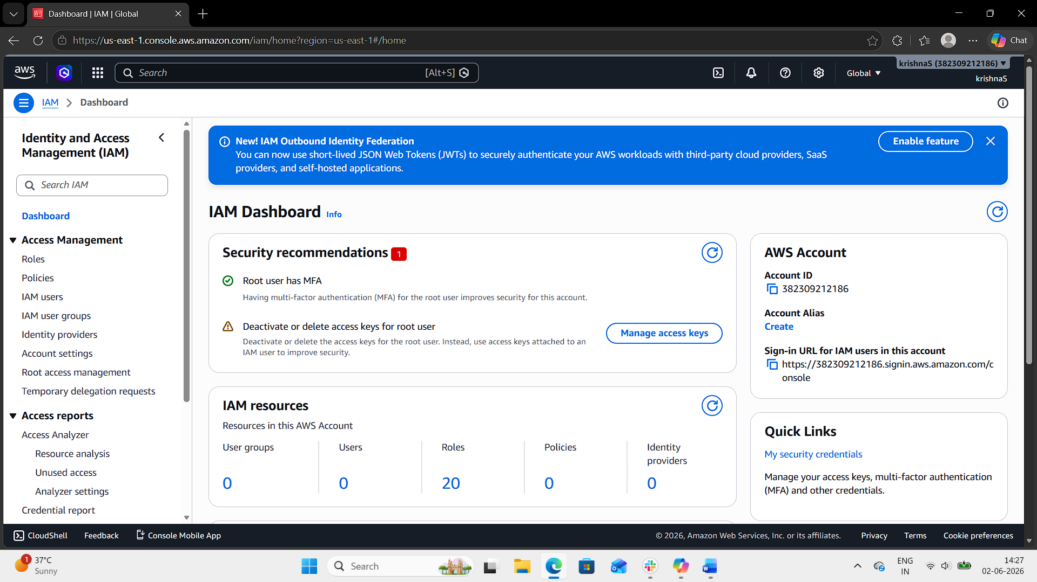
Step 2: Create IAM User
- In the IAM dashboard, click IAM Users → Click Create user.
- Enter a username (e.g., ec2-s3-user).
- Select Access type AWS Management Console access.
- Select custom password and enter password.
- Users must create a new password at next sign-in.
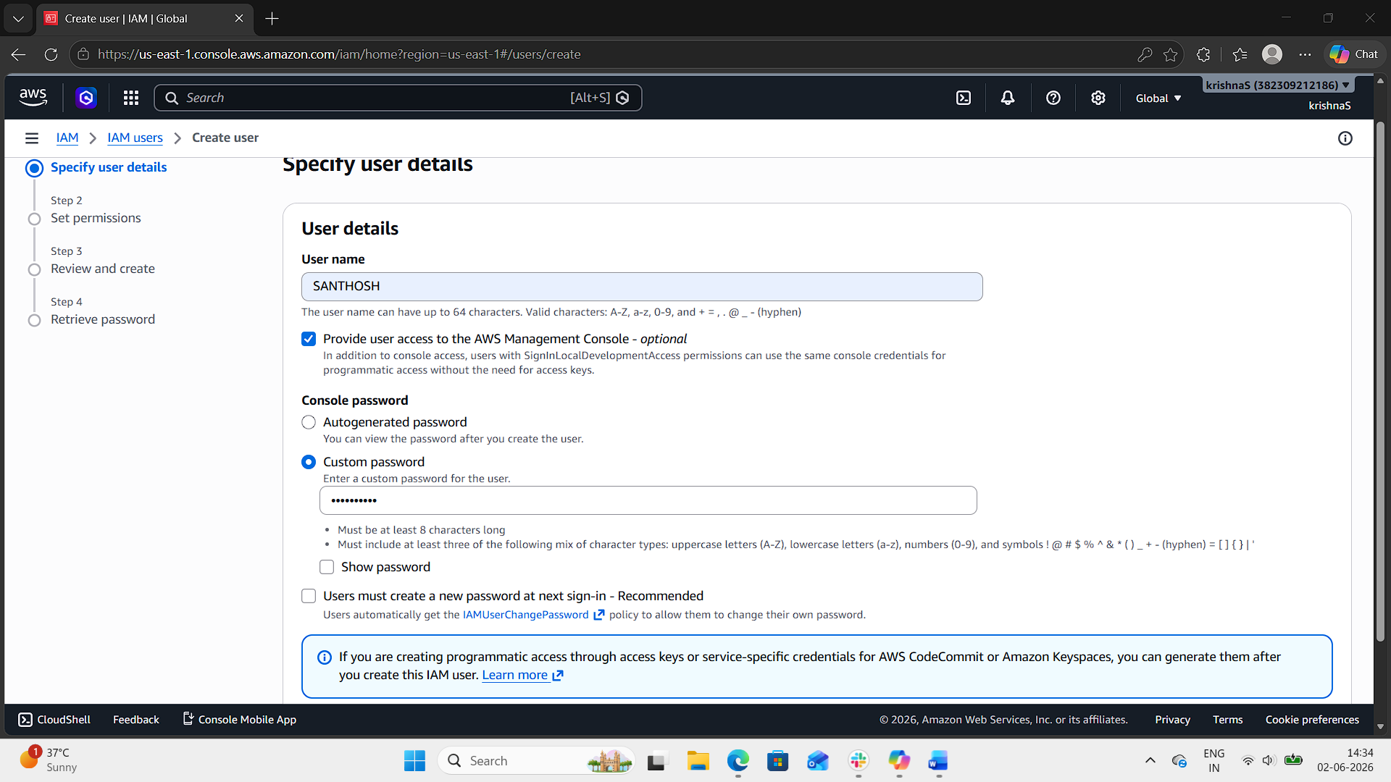
Step 3: Attach Policies
- On the Permissions step, choose Attach policies directly.
- Search and select:
  - AmazonEC2FullAccess
  - AmazonS3FullAccess
- Click Next → Review → Create user.
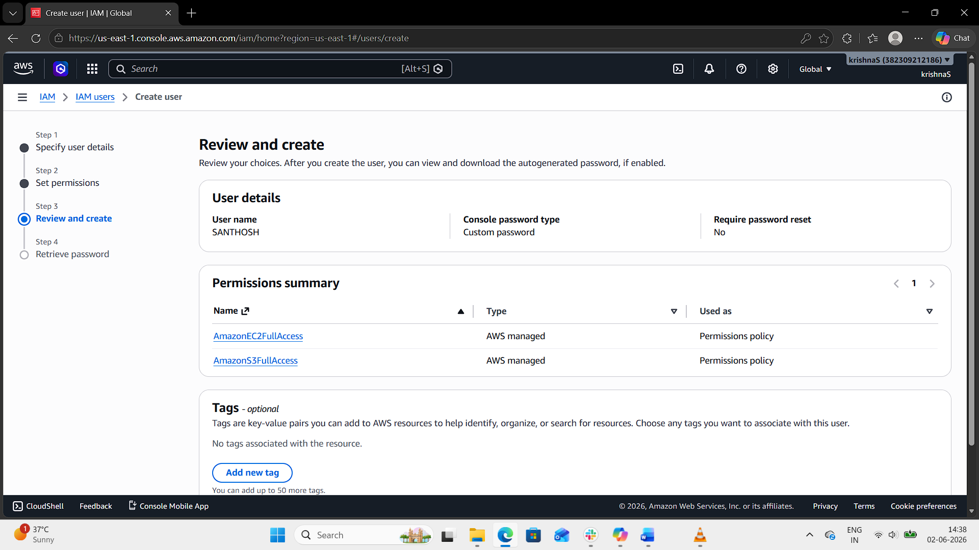
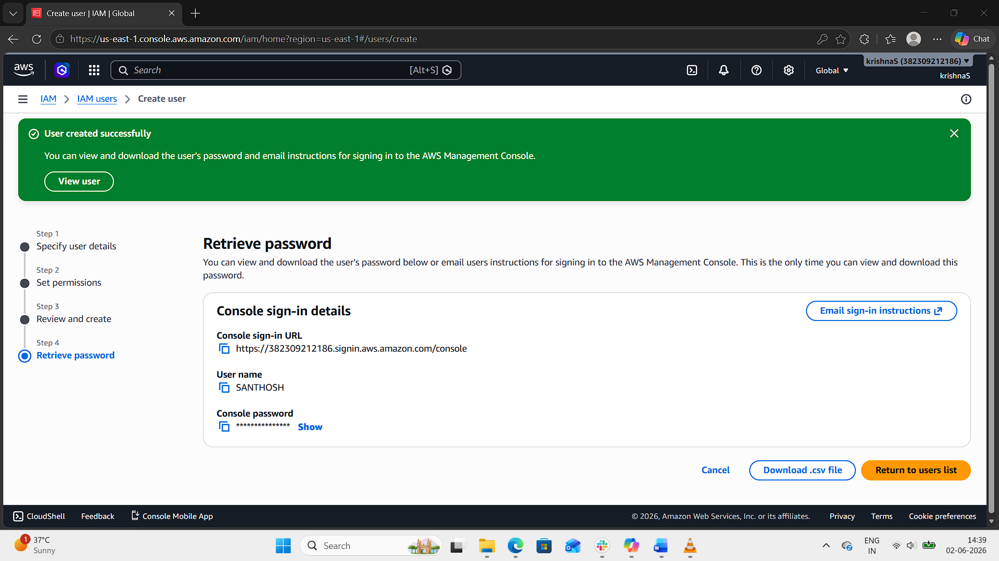
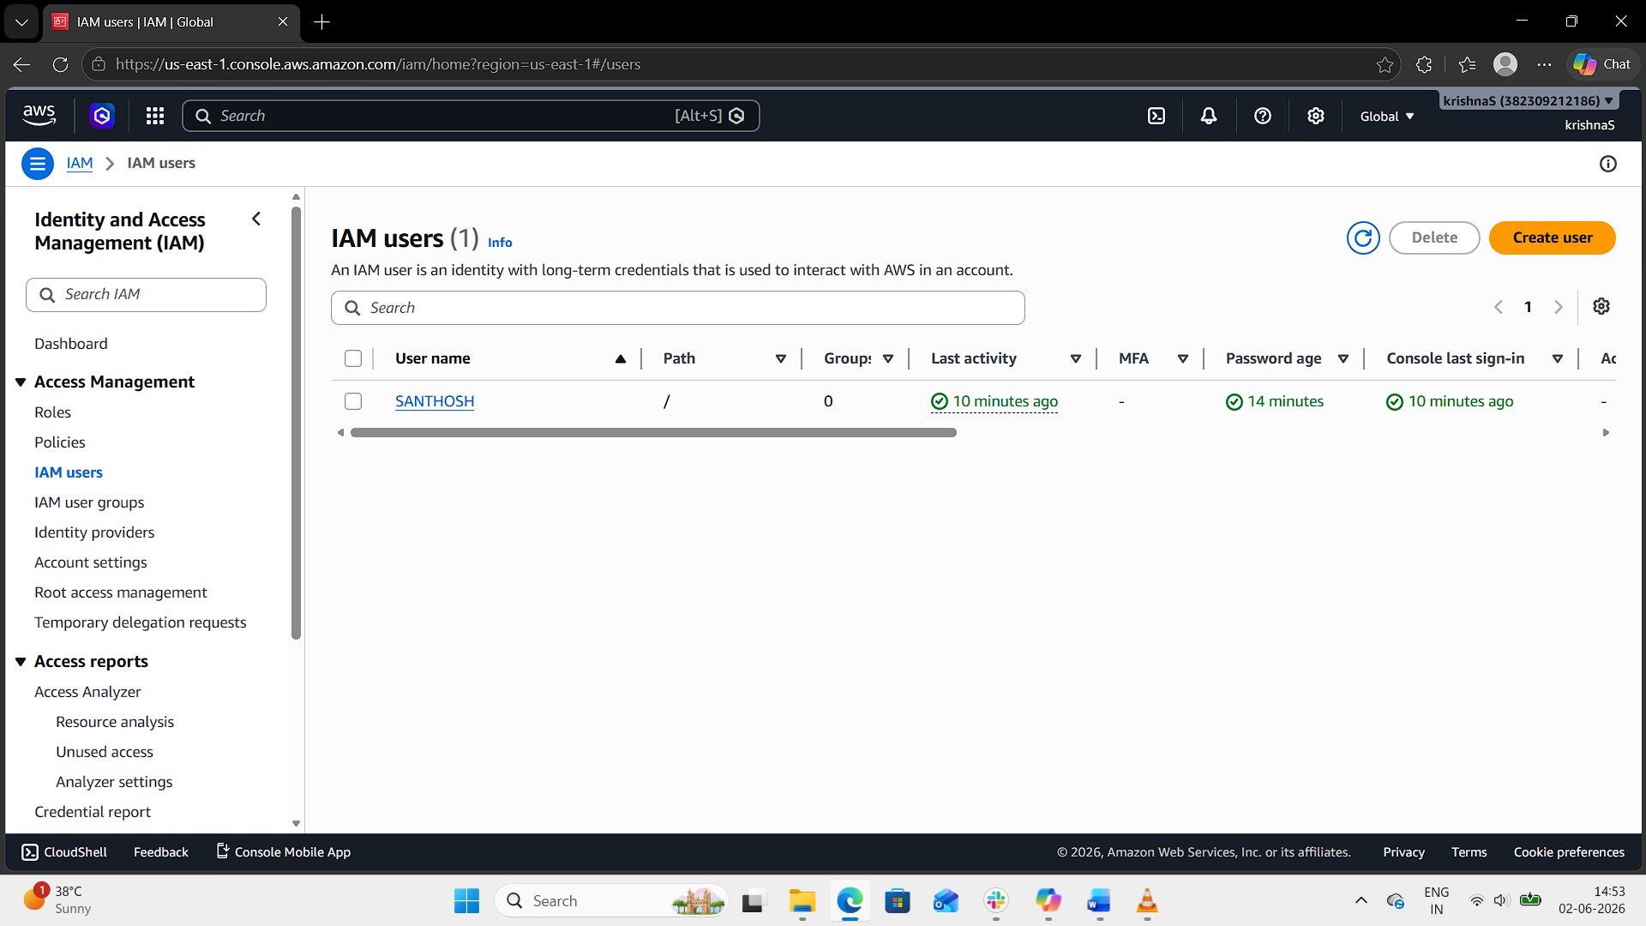
Step 4: Save Credentials
- If you enabled programmatic access, download the .csv file with Access Key ID and Secret Access Key.
- Store them securely — you’ll need them for CLI/SDK authentication.
Step 5: Verify Access
- Log in with the new IAM user credentials.
- Test by running:
  - In git bash
  - aws s3 ls
  - aws ec2 describe-instances
- These commands should work if the policies are correctly attached.
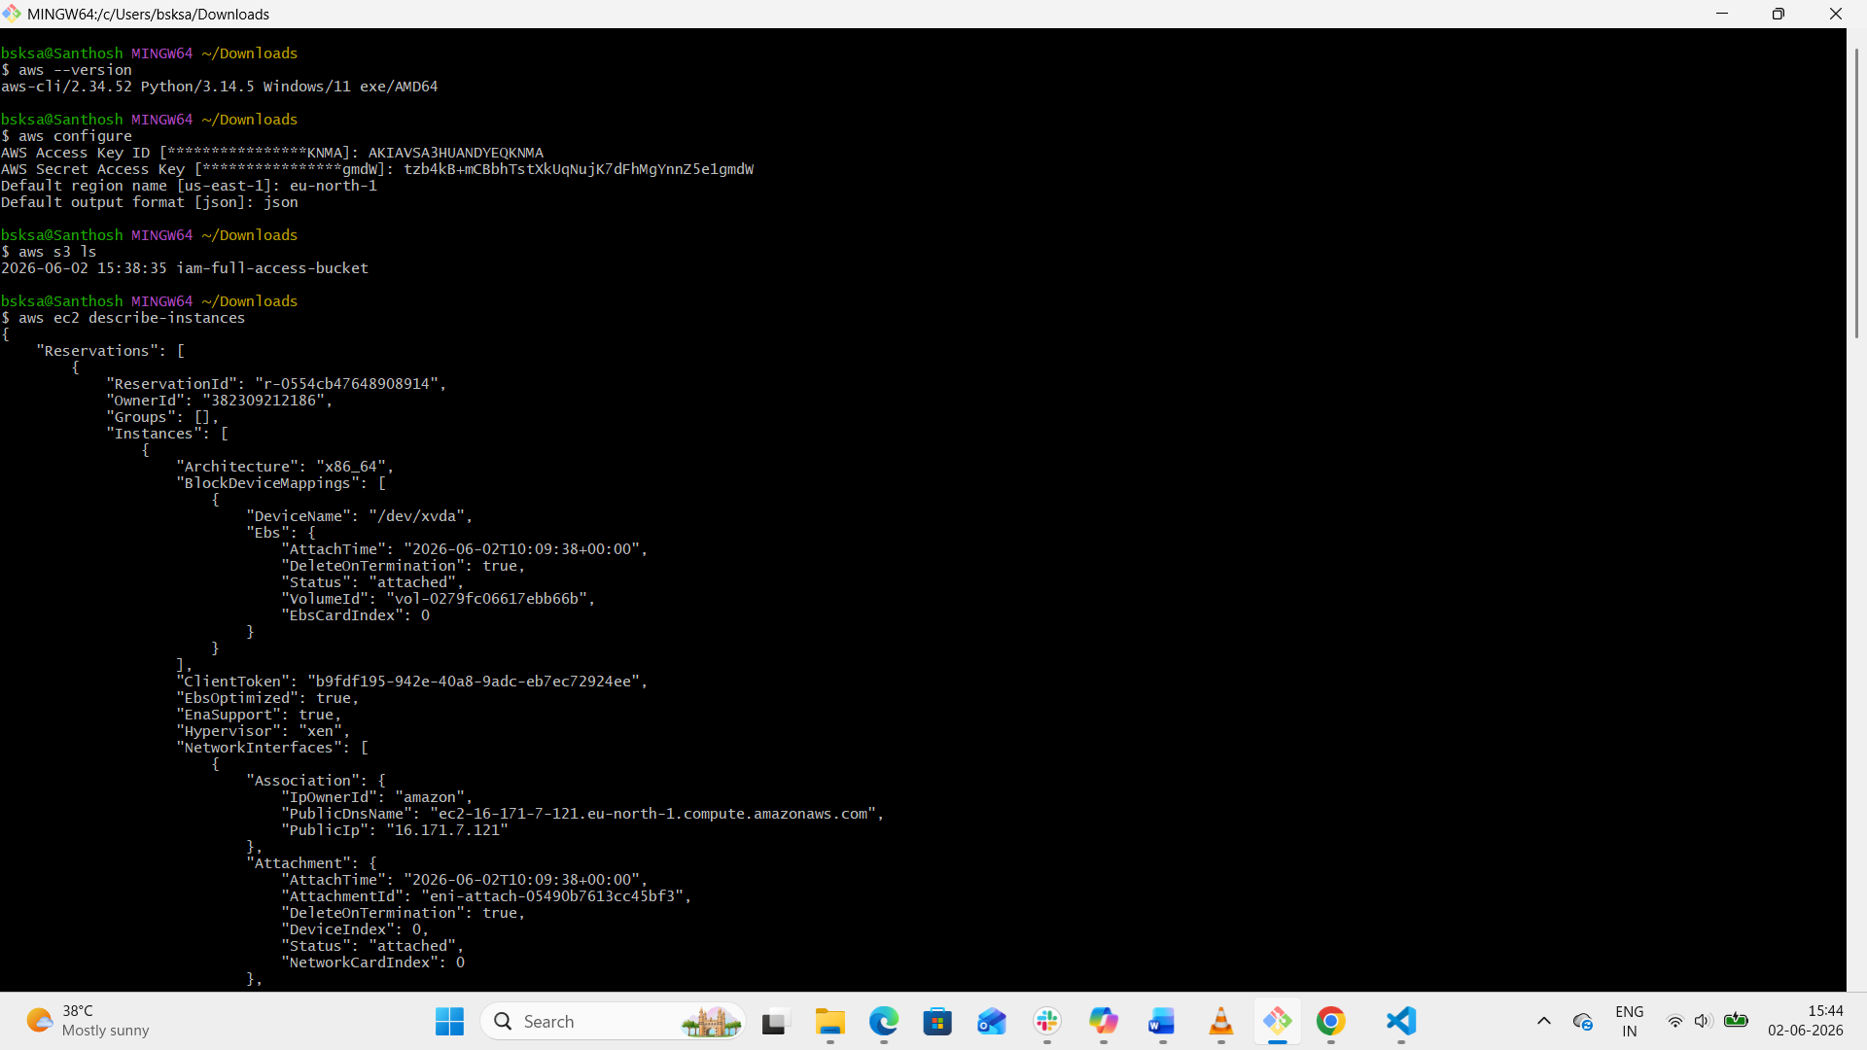
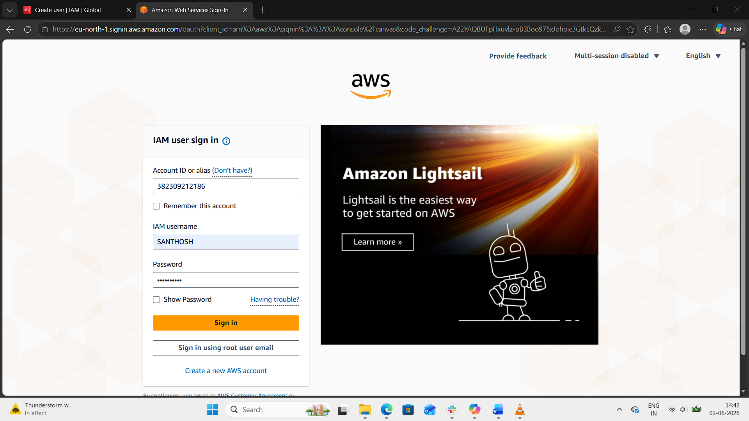
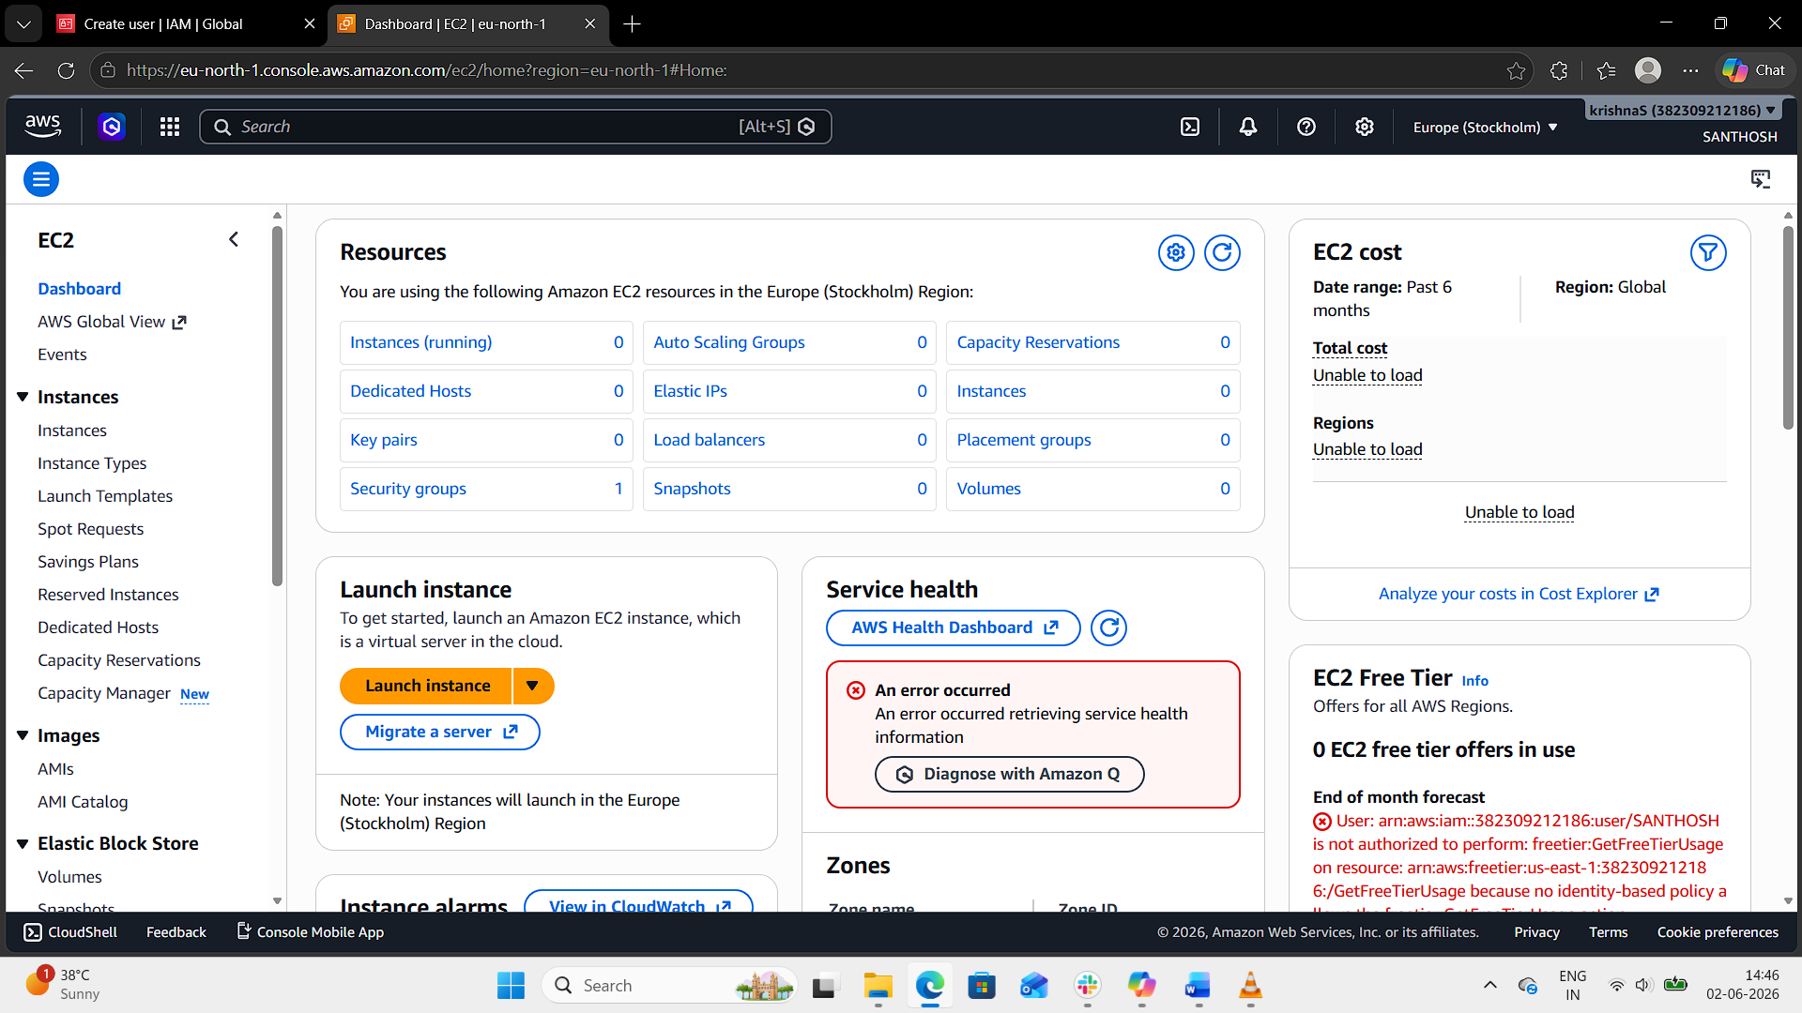
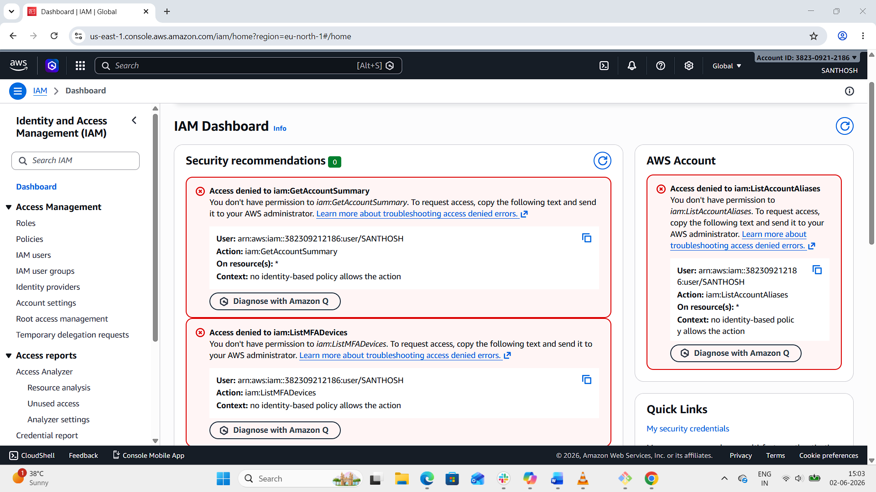
2. Create one group in IAM and assign read access for EC2.
Step 1: Open IAM in AWS Console
- Sign in to the AWS Management Console.
- Go to IAM (Identity and Access Management).
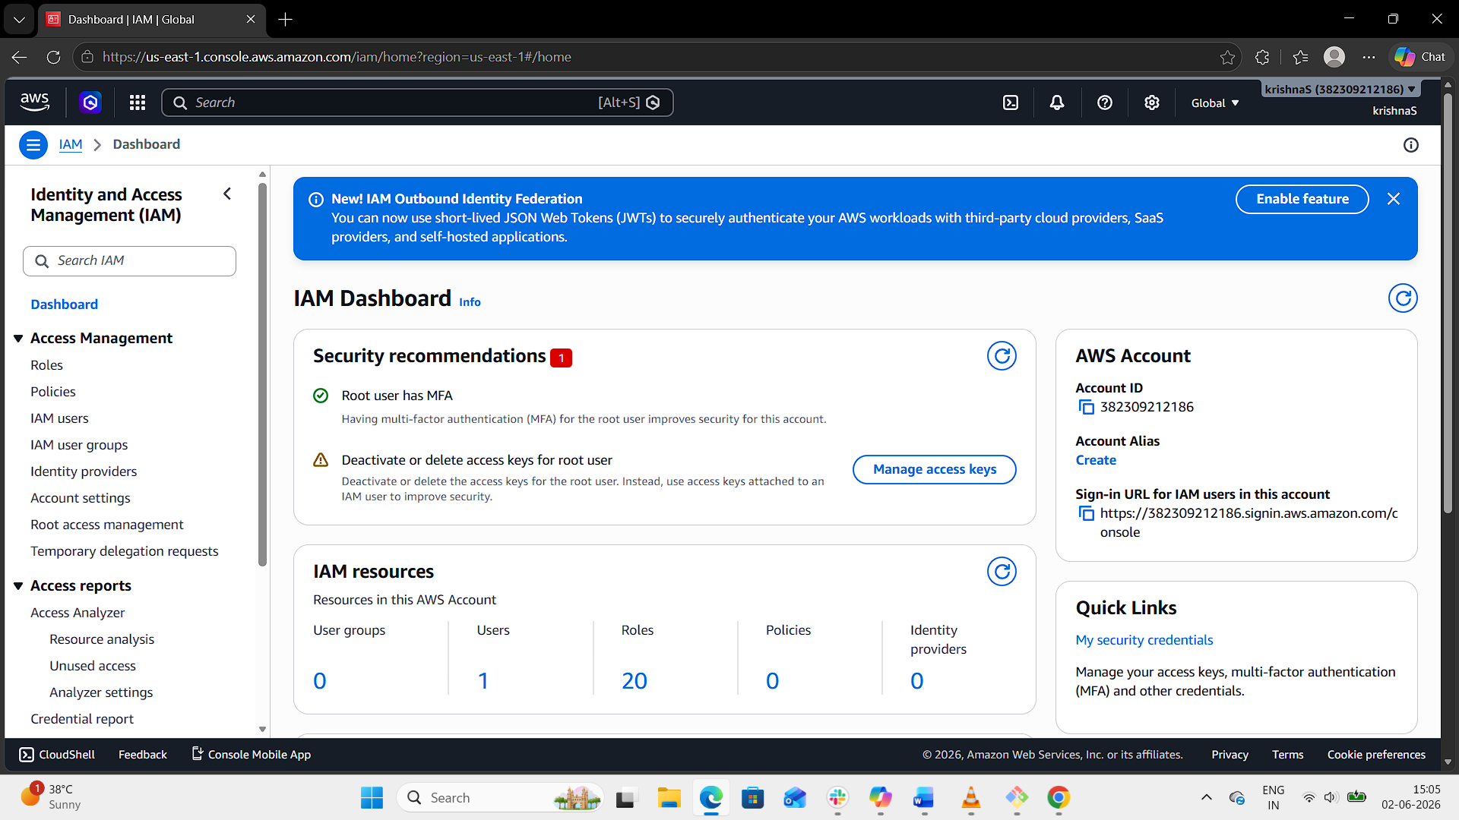
Step 2: Create a Group
- In the IAM dashboard, click IAM User groups → Create group.
- Enter a Group name: test-group
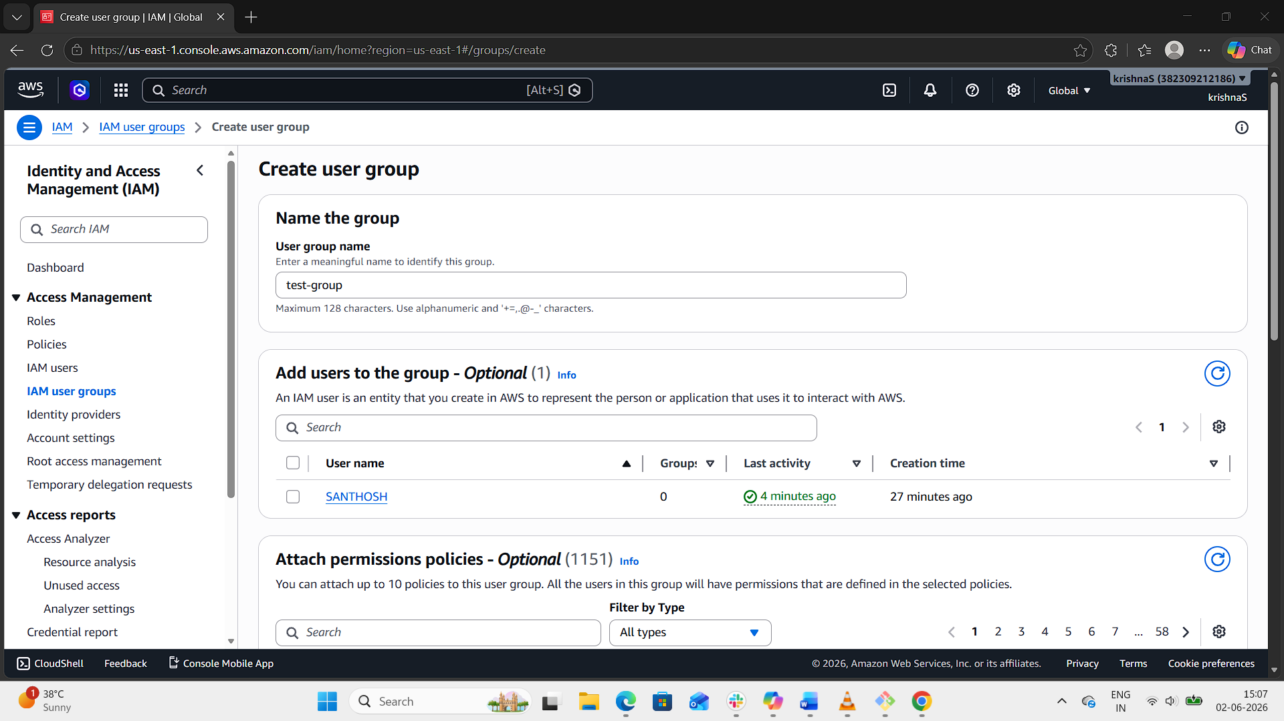
Step 3: Attach Policy
- In the Attach permissions policies step, search for:
  - AmazonEC2ReadOnlyAccess
- Select the policy and click Create group.
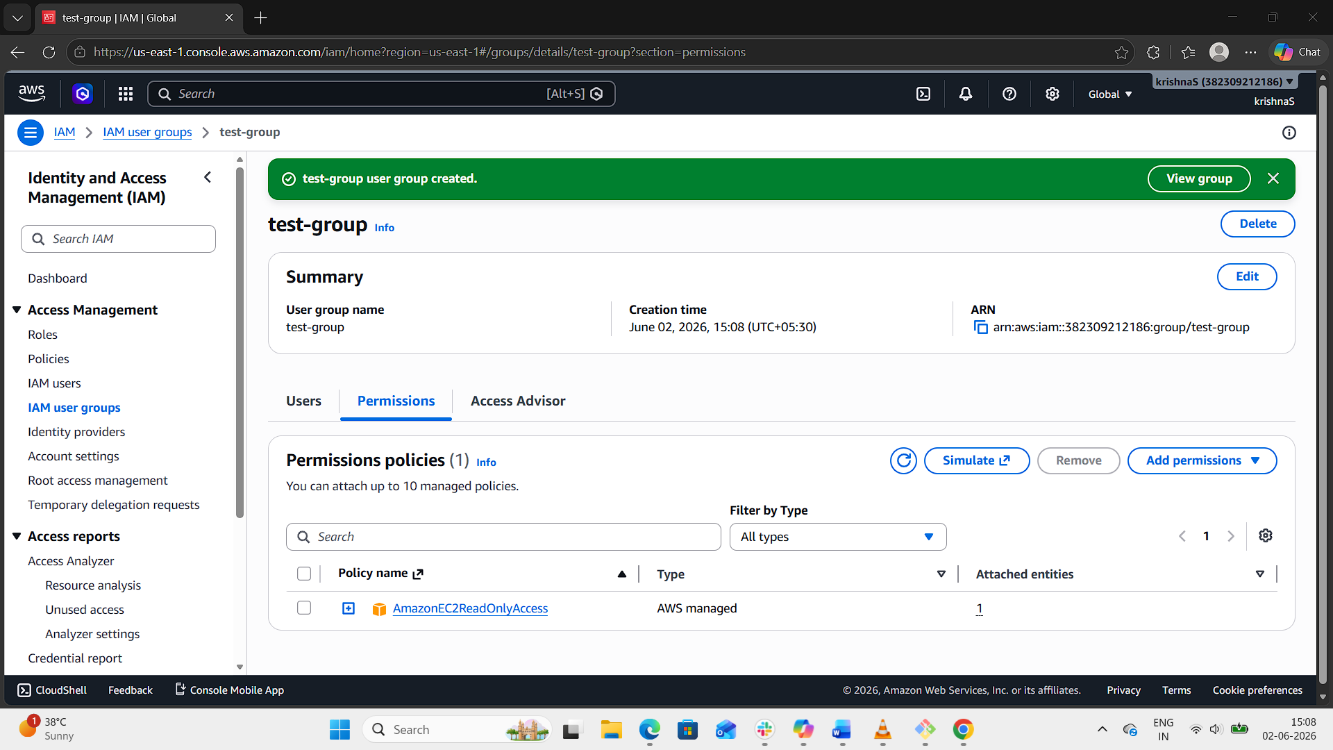
3. Create a new user named "Devops" and add to the group created in task 2.
Step 1: Create IAM User
- In the IAM dashboard, click IAM Users → Click Create user.
- Enter a username: Devops
- Select Access type AWS Management Console access.
- Select custom password and enter password.
- Check with Users must create a new password at next sign-in or else uncheck it.
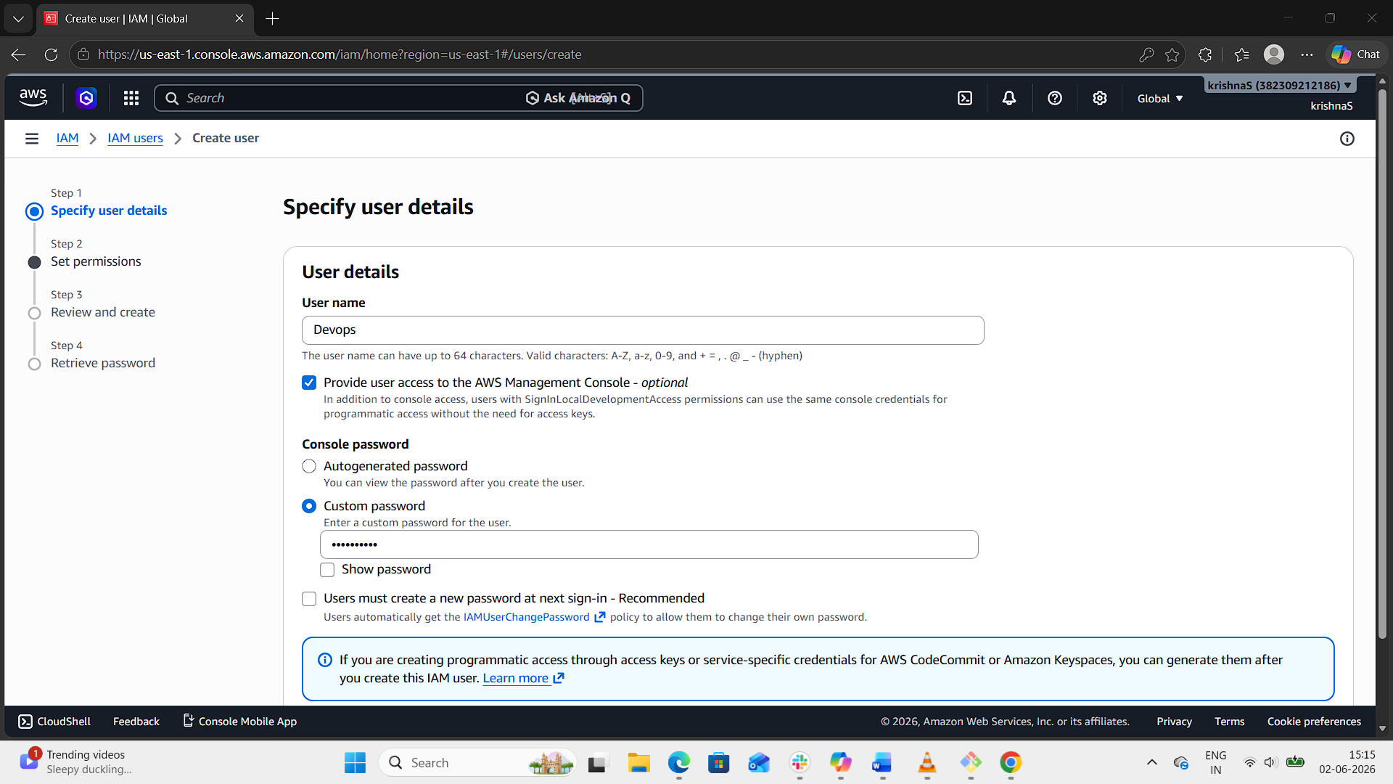
Step 2: Add user to group
- On the Permissions step, choose Add user to group.
- Select the group you created earlier: test-group.
- Next → Review → Create user.
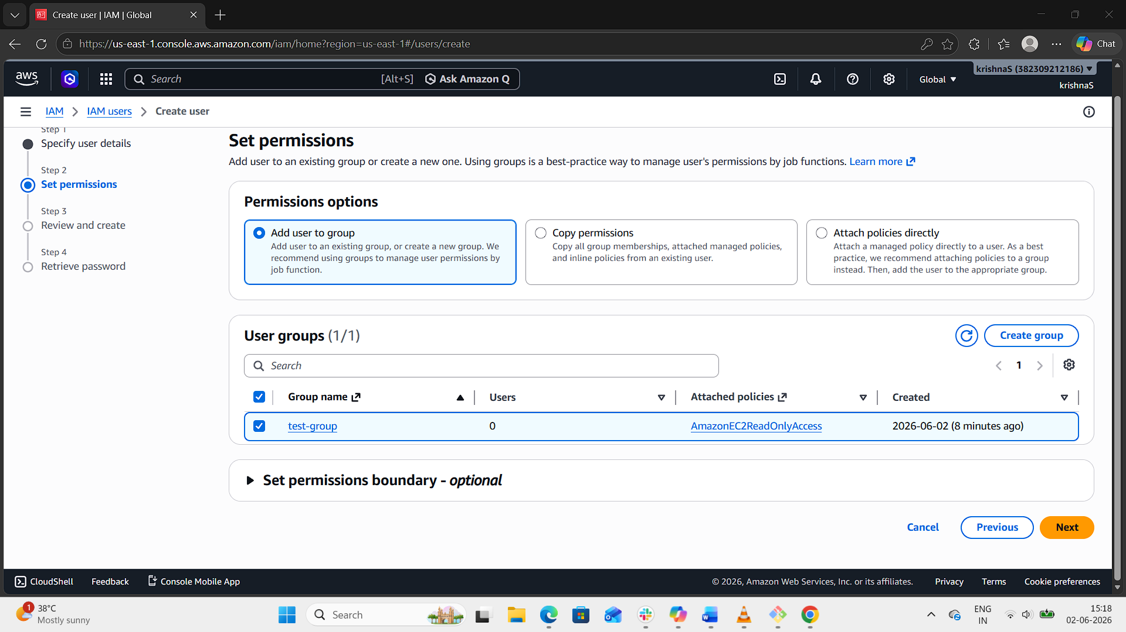
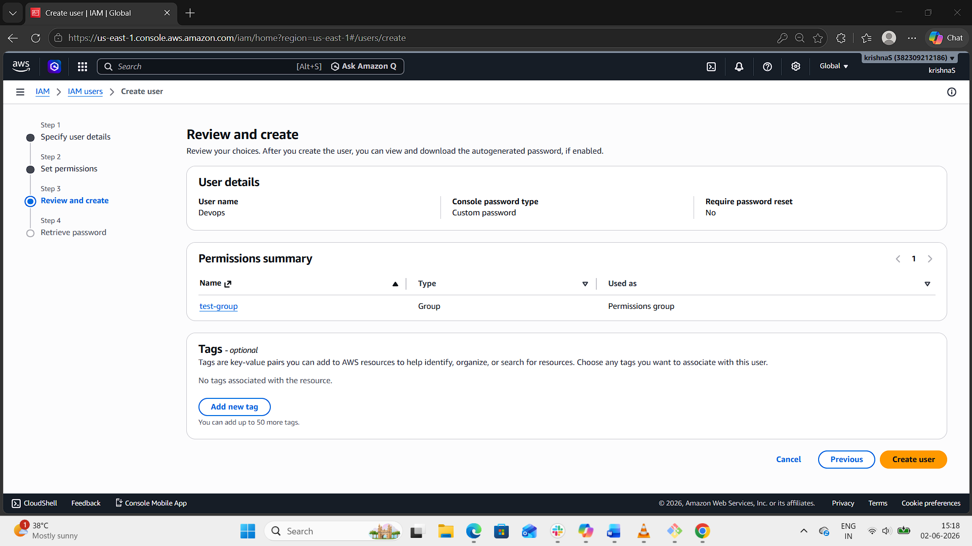
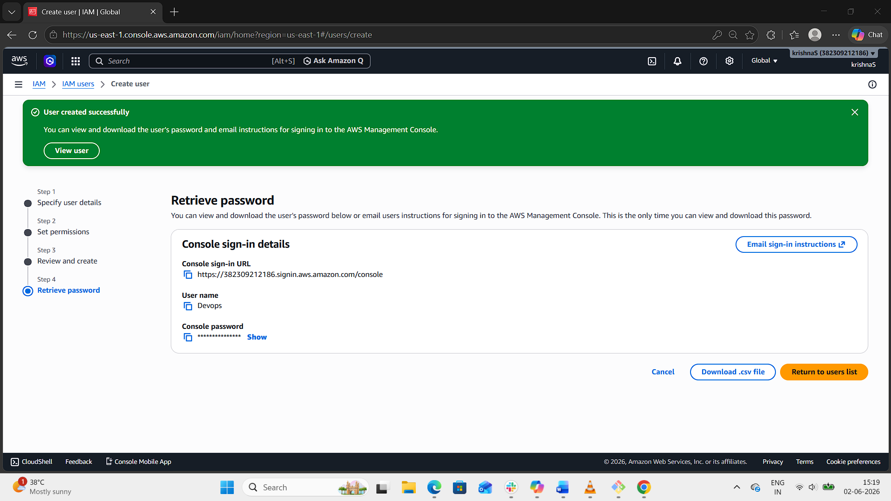
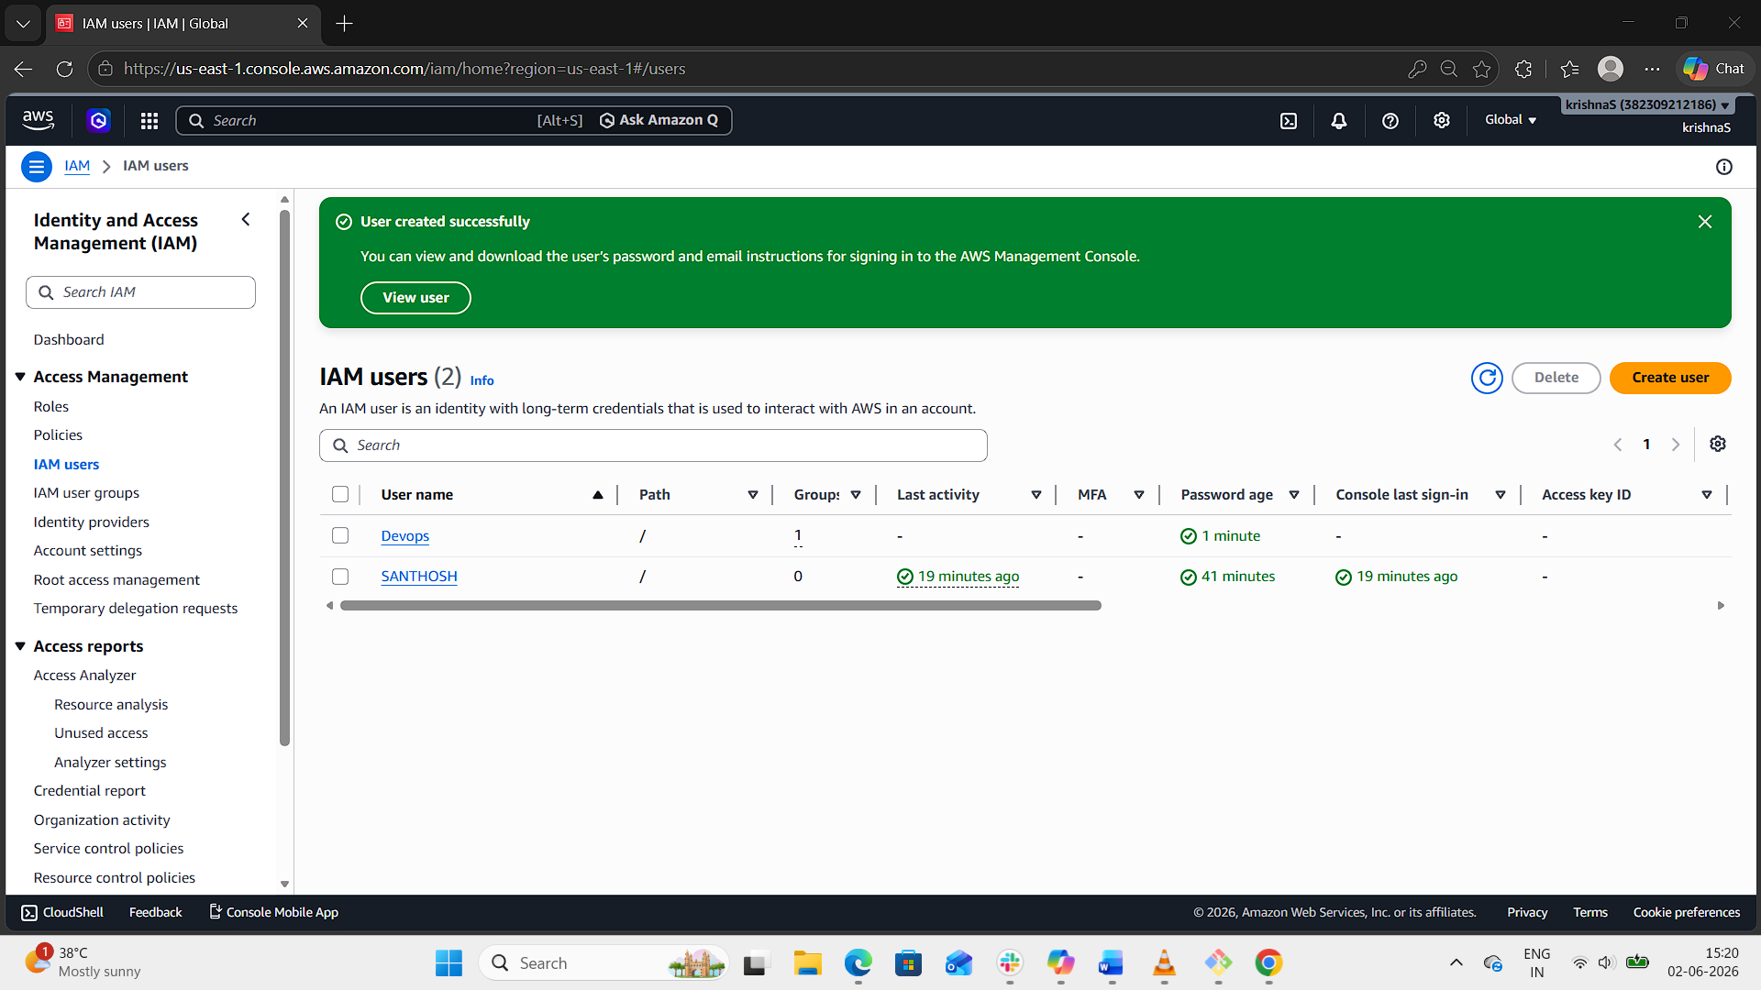
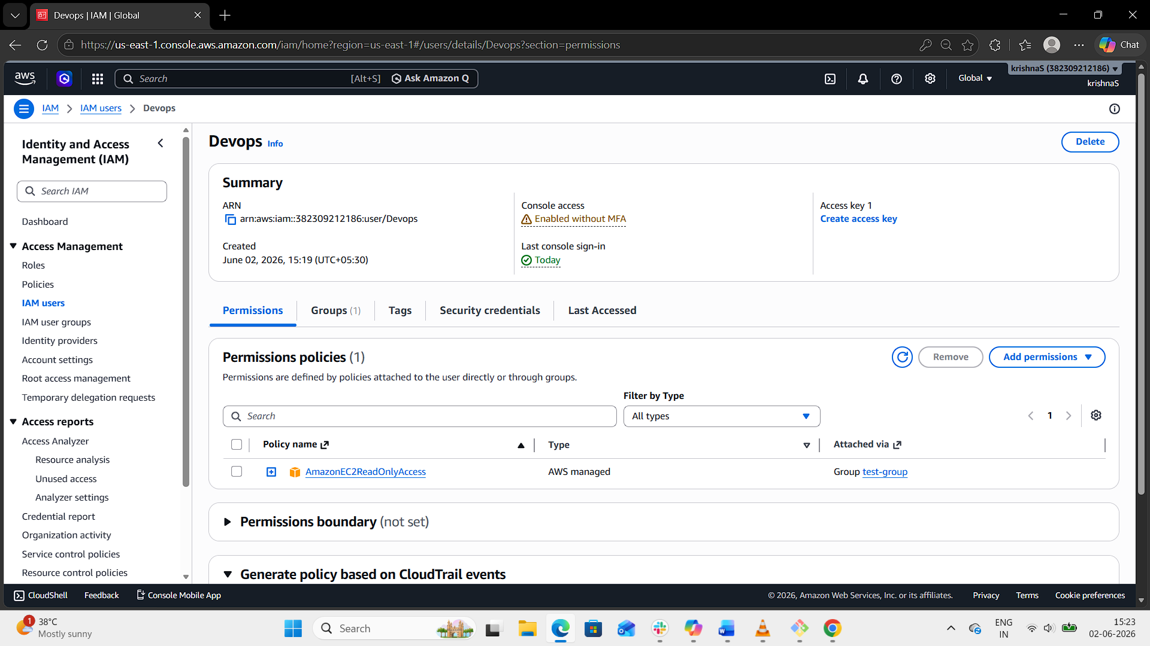
Step 4: Save Credentials
- If you enabled programmatic access, download the .csv file with Access Key ID and Secret Access Key.
- Store them securely — you’ll need them for CLI/SDK authentication.
Step 5: Verify Access
- Log in as Devops.
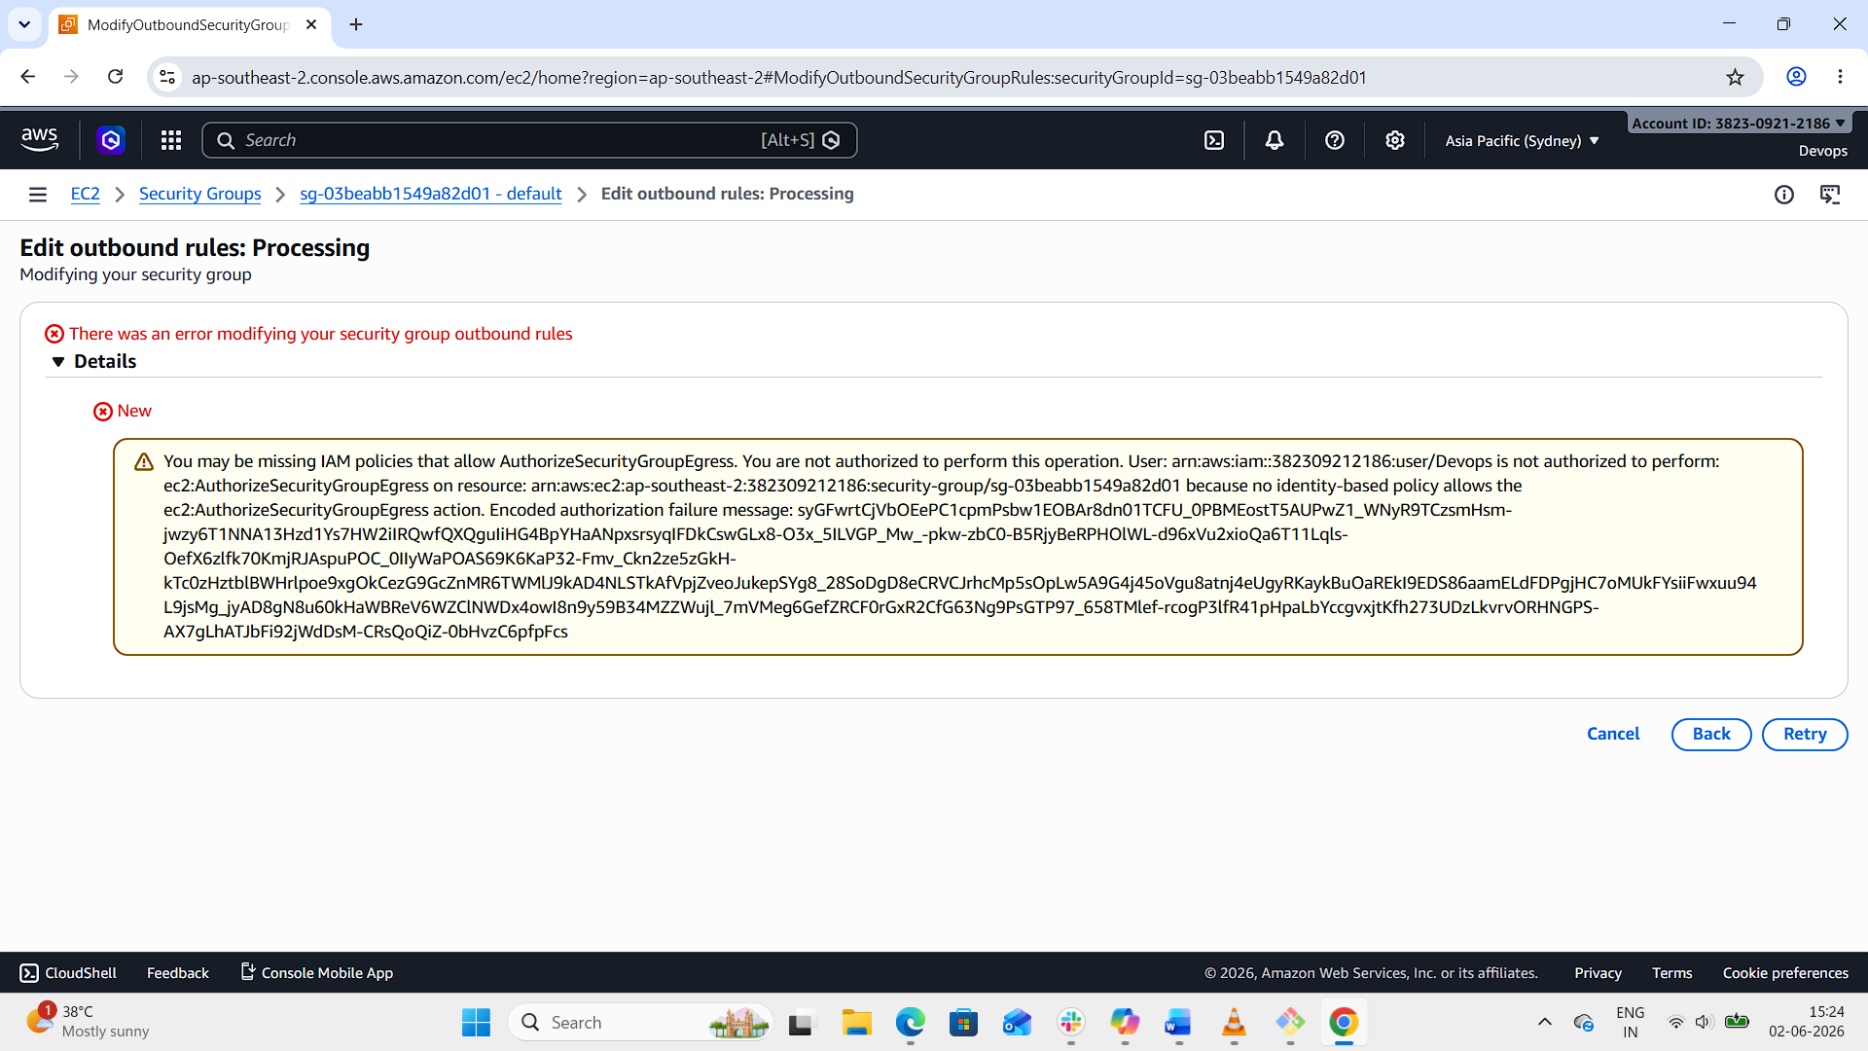
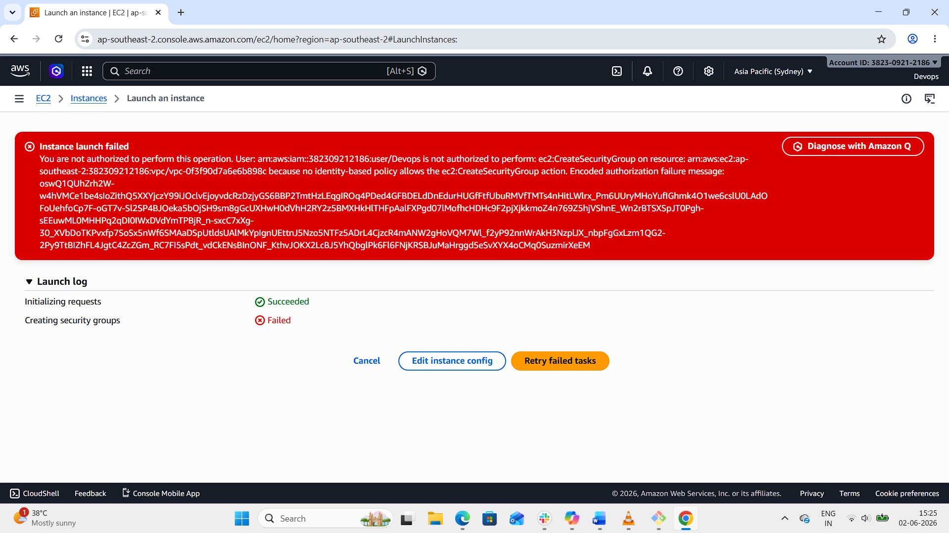
4. Write a bash script to create an IAM user with VPC full access.
- In Git bash, configure the aws cli by aws configure command.
- After configuration, create a bash file to write a script to create a user with VPC full access.
- Change the permission of that .bash file.
- Then verify the user is created or not in AWS console.
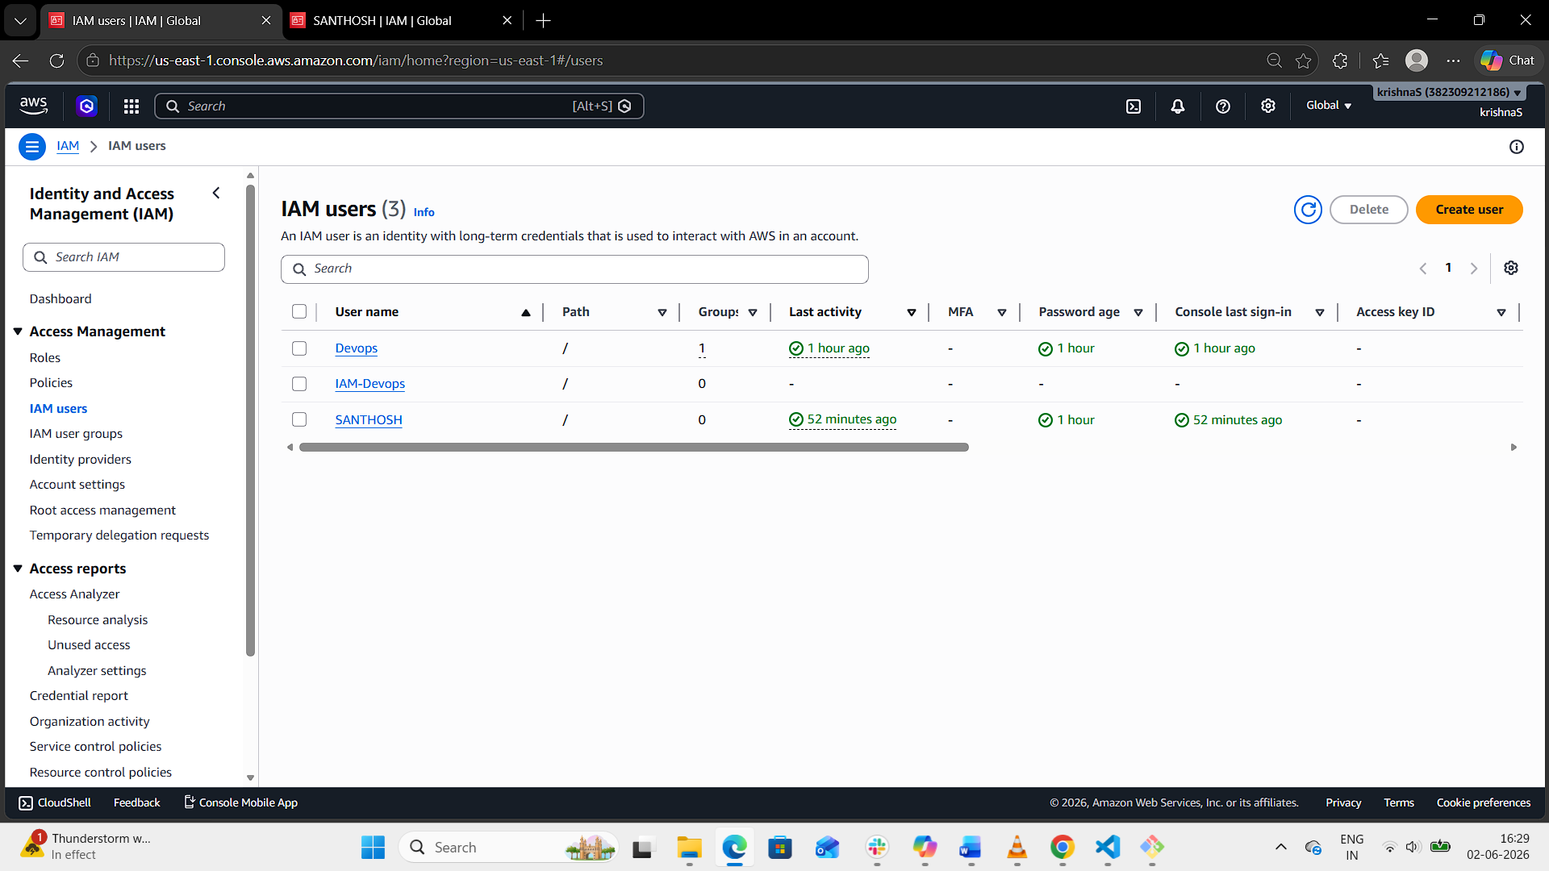
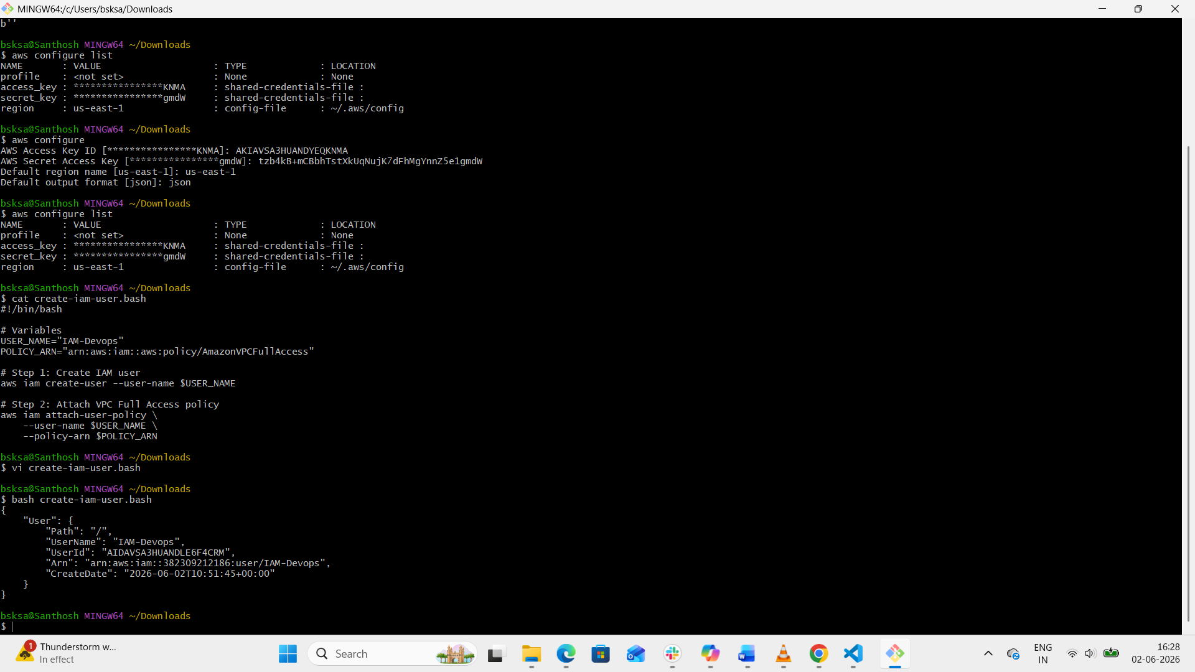
5. Create an IAM policy to allow EC2 access for a specific user in specific regions only.
Step 1: Open IAM Policy Section
1. Go to AWS Console
2. Search → IAM
3. Click Policies
4. Click Create policy
Step 2: Switch to JSON Tab
Delete default editor and paste this policy
Step 3: What This Policy Means
Allows:
- Full EC2 access (ec2:*)
- ONLY in region: us-east-1
Blocks:
- EC2 actions in all other regions (like ap-south-1, us-east-1)
Step 4: Create Policy
1. Click Next
2. Name the policy:
IAM-policy-specific-region
3. Click Create policy
Step 5: Attach Policy to User
1. Go to IAM Users→
2. Select your user IAM-Devops
3. Click Permissions
4. Click Add permissions
5. Choose:
o Attach policies directly
6. Select:
o IAM-policy-specific-region
7. Click Add permissions
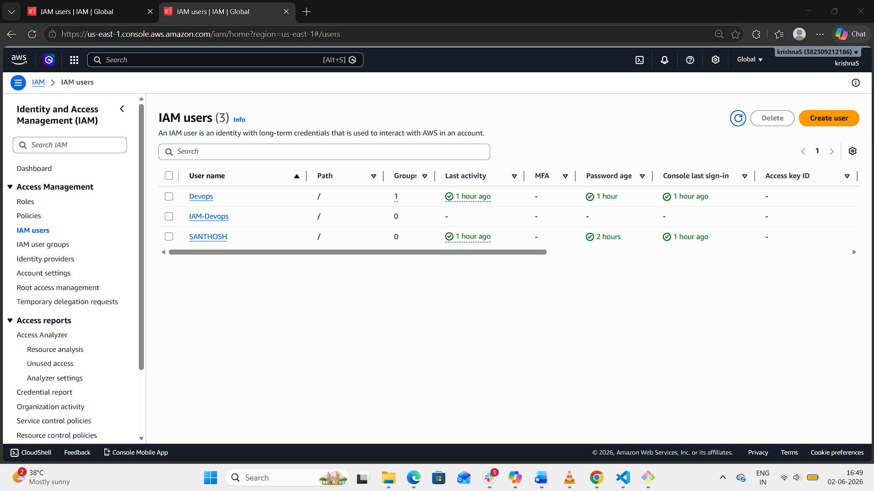
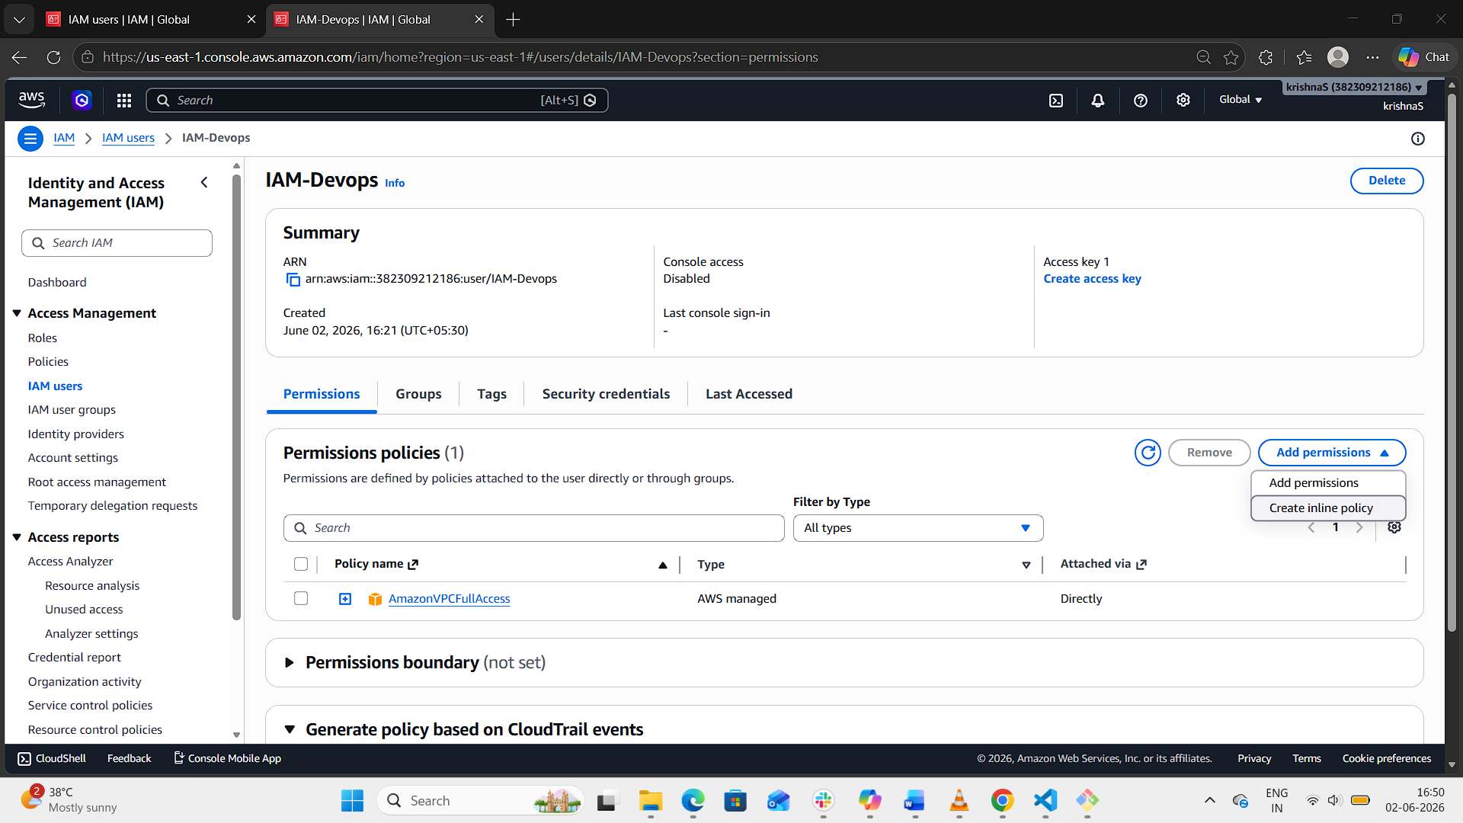
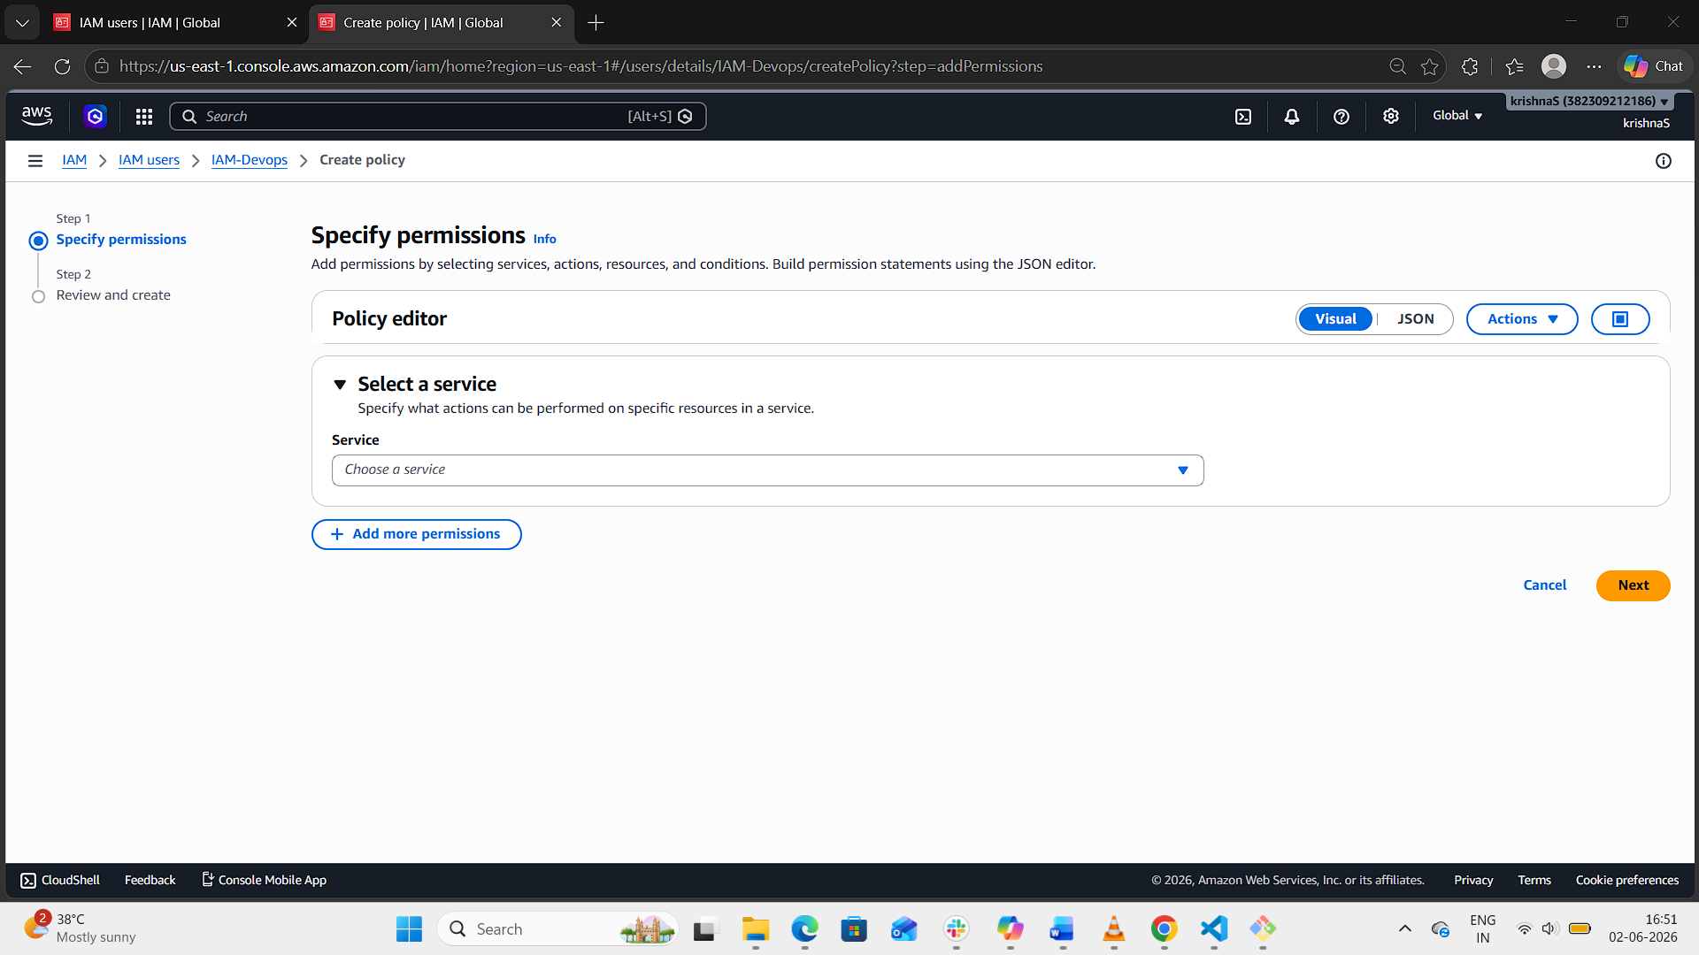
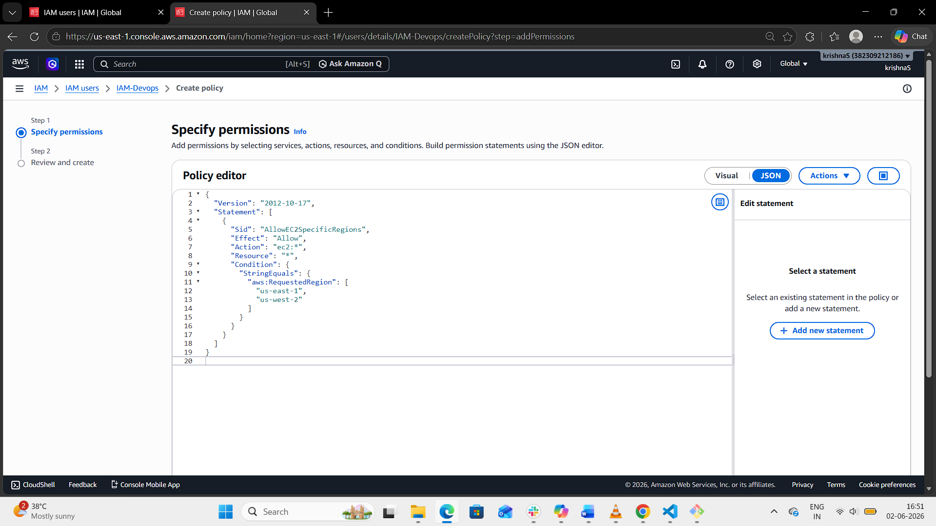
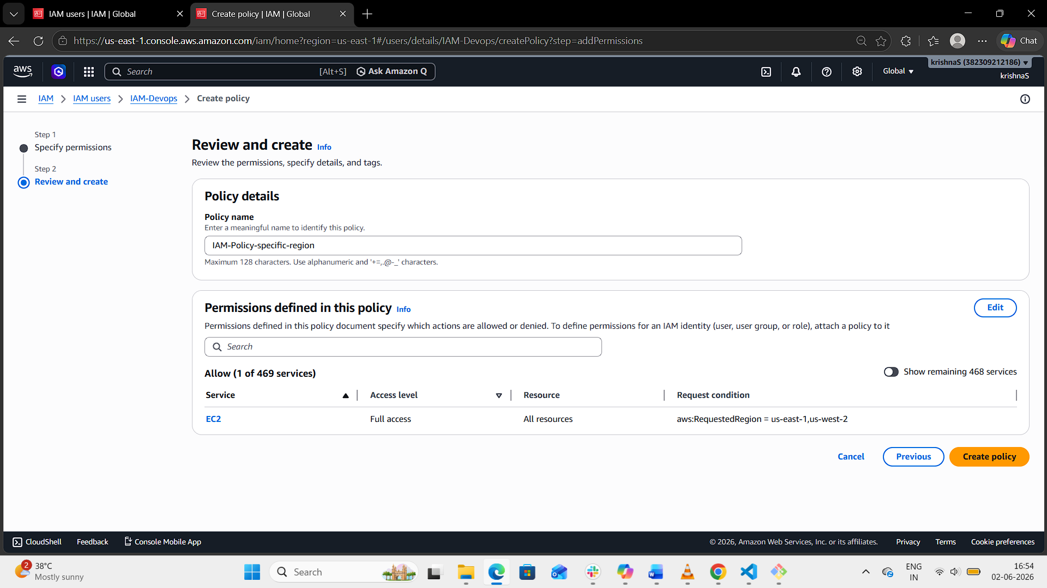
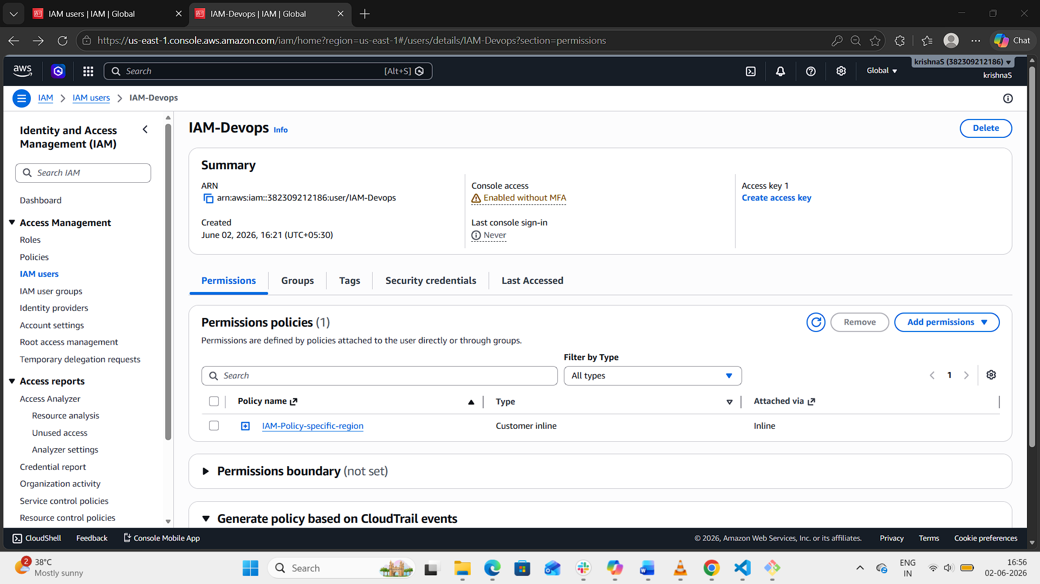
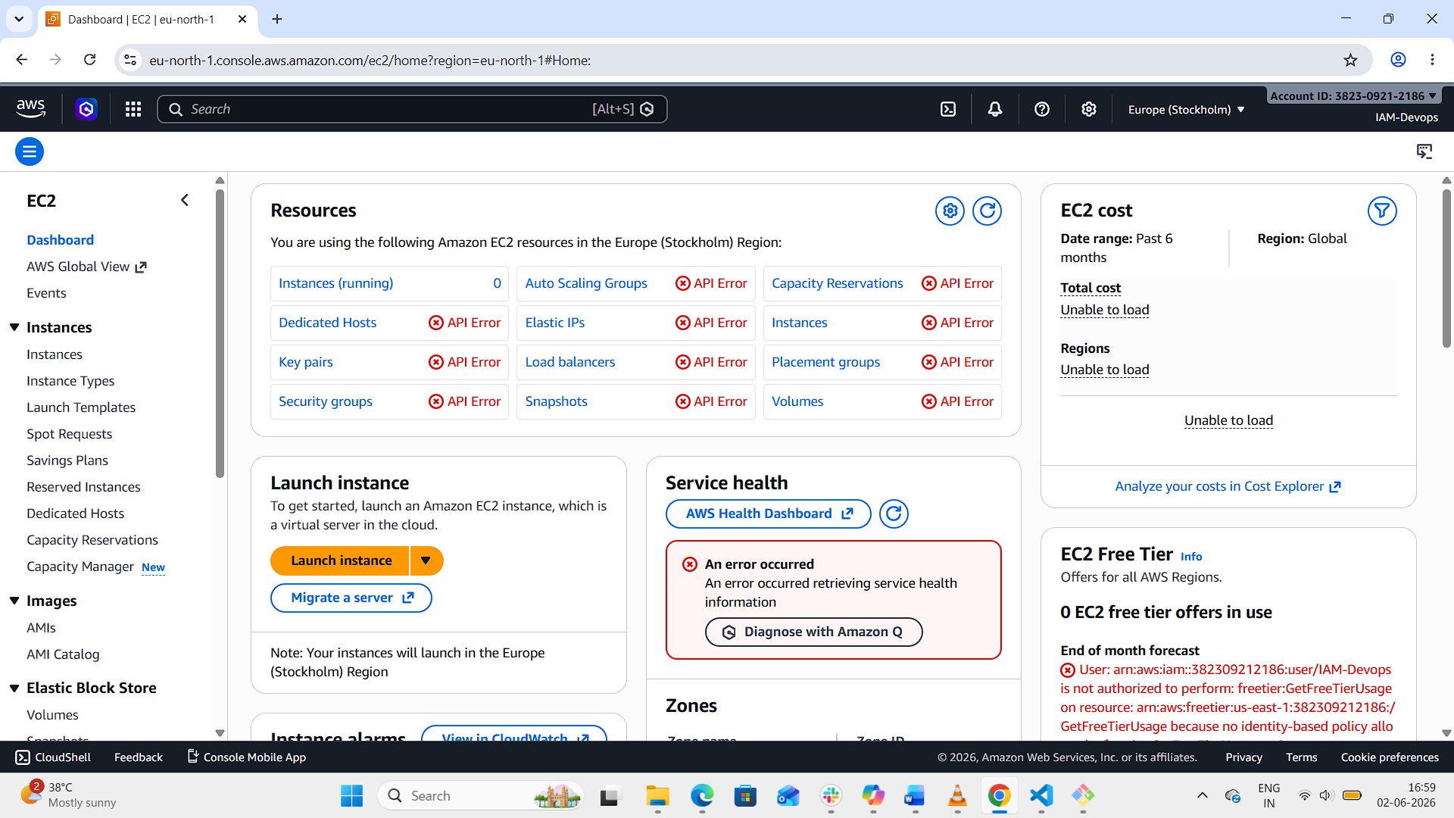
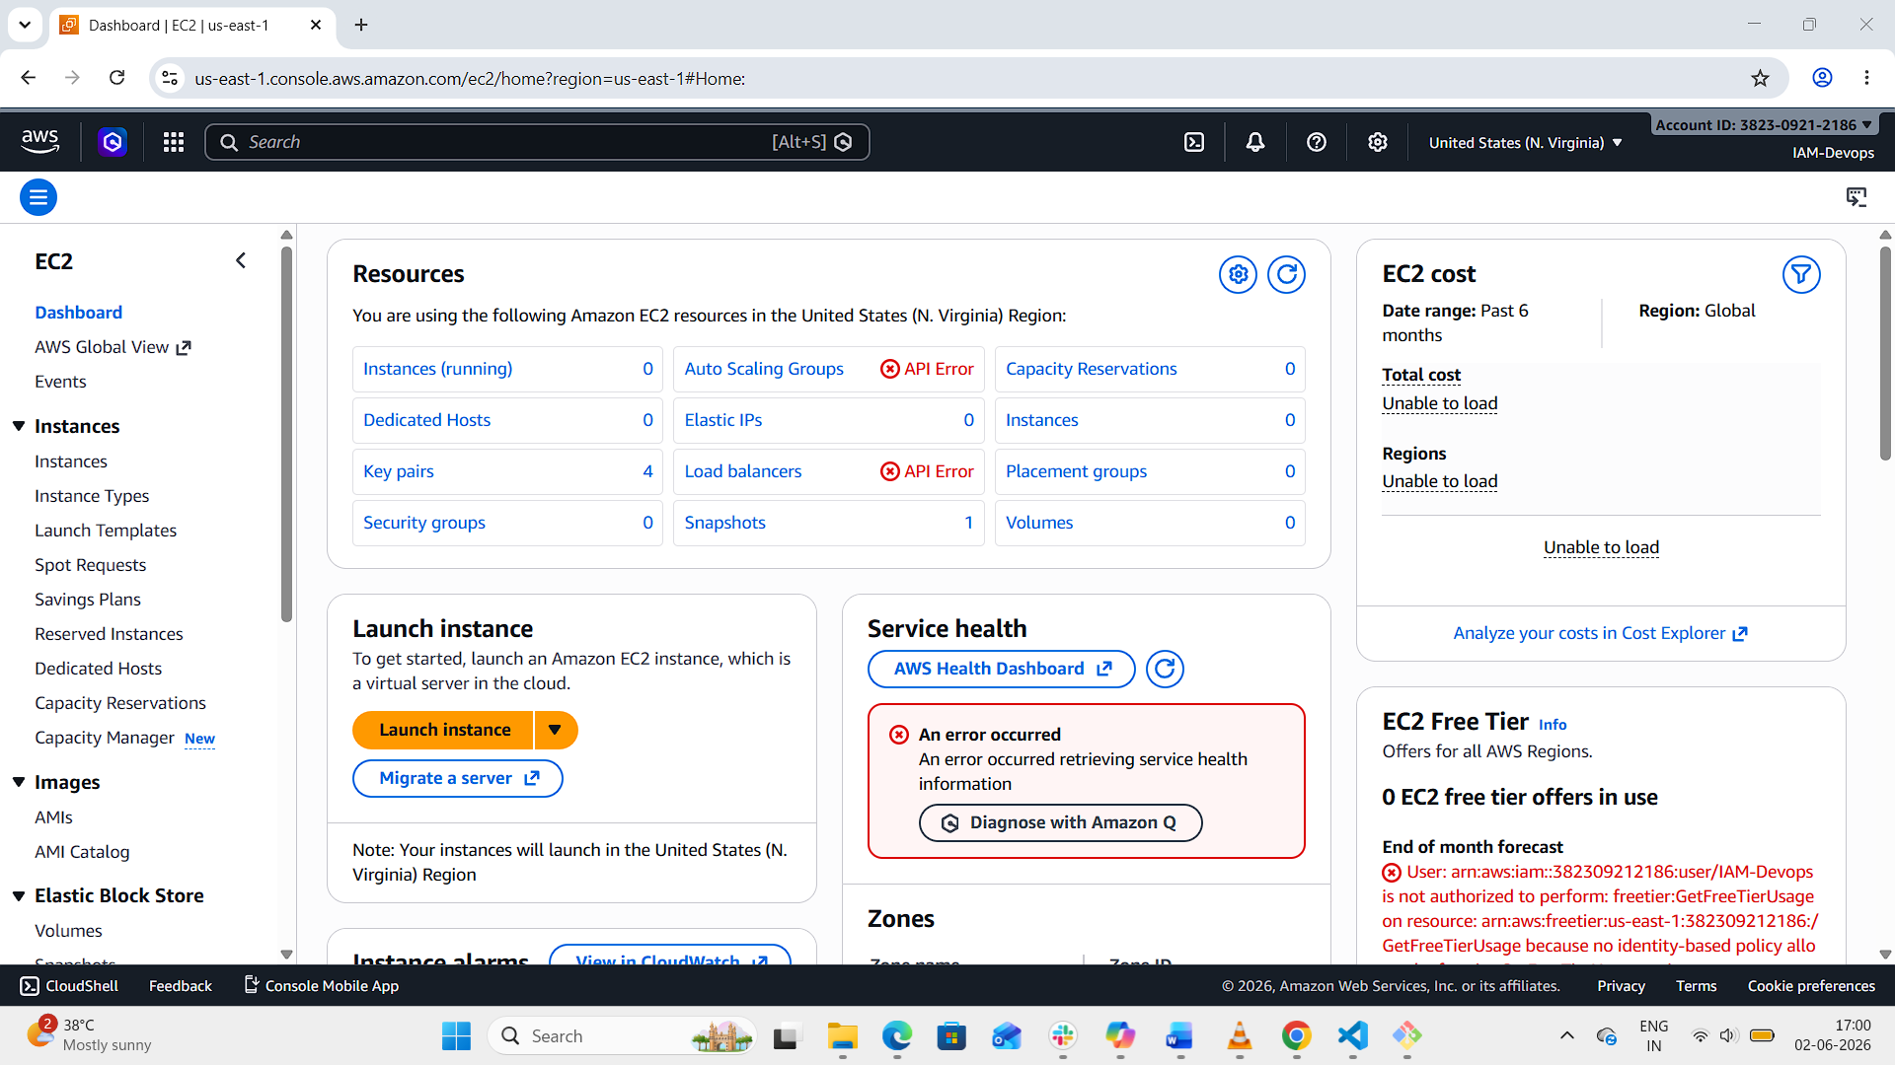
6. We have two accounts: Account A and Account B. Account A user should access an S3 bucket in Account B.
(Collaborate with a team member and execute this. This is mostly asked in every interview.)
Step 1: Create IAM Policy in Account A
Attach this policy to the Account A user (Myy-cross-user):
json
{
"Version": "2012-10-17",
"Statement": [
{
"Sid": "AllowS3CrossAccountAccess",
"Effect": "Allow",
"Action": [
"s3:GetObject",
"s3:ListBucket"
],
"Resource": [
"arn:aws:s3:::bucket-in-account-b",
"arn:aws:s3:::bucket-in-account-b/*"
]
}
]
}
- Replace bucket-in-account-b with the actual bucket name in Account B.
- This policy allows the user to list the bucket and read objects.
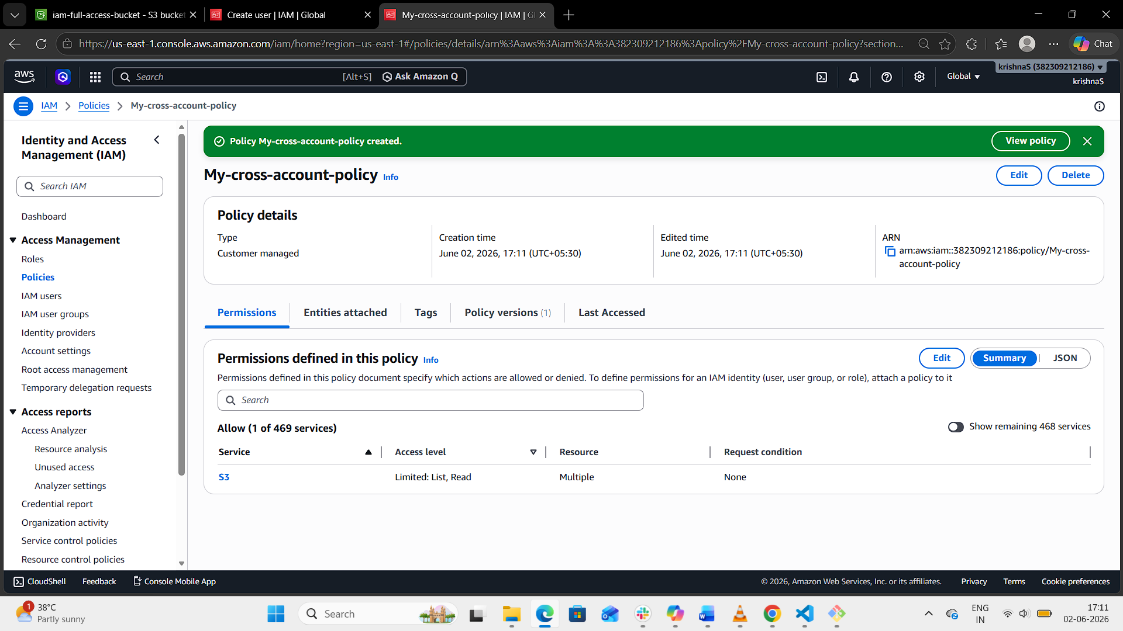
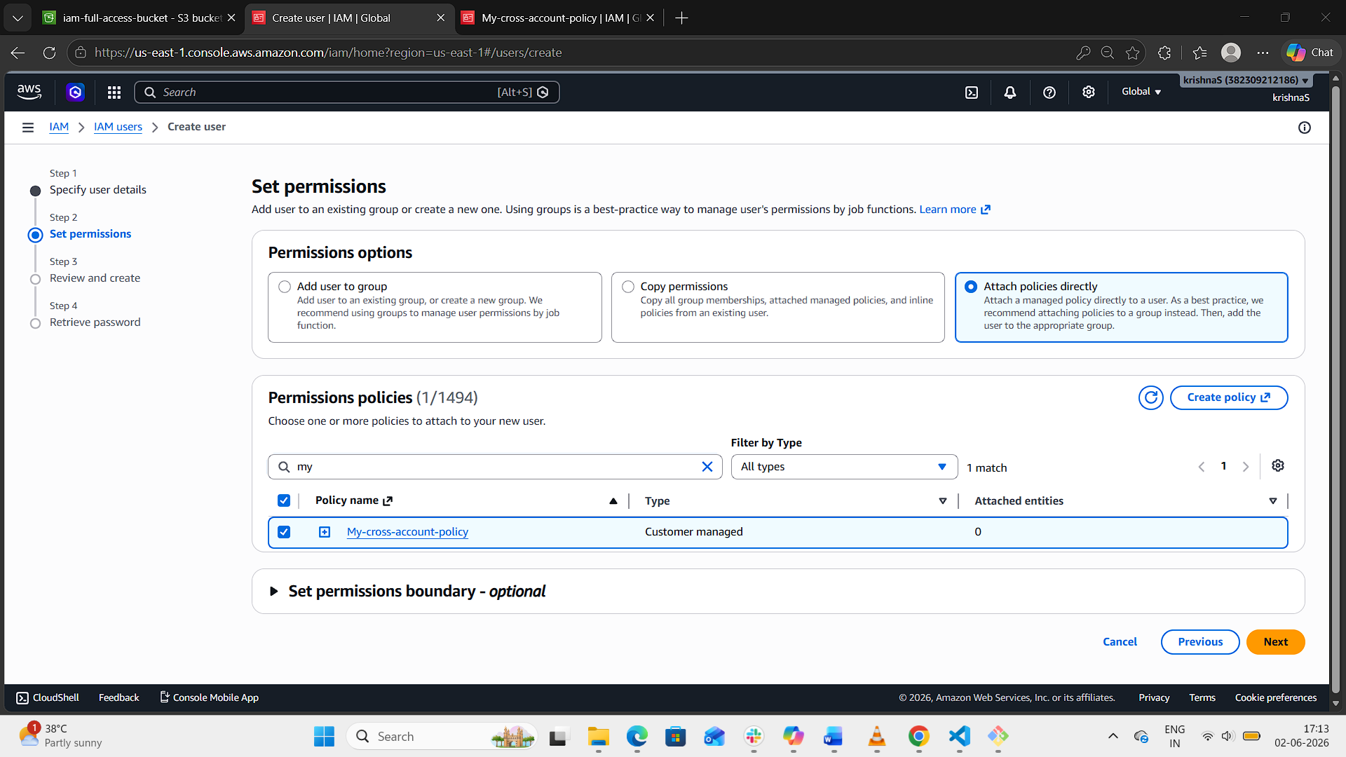
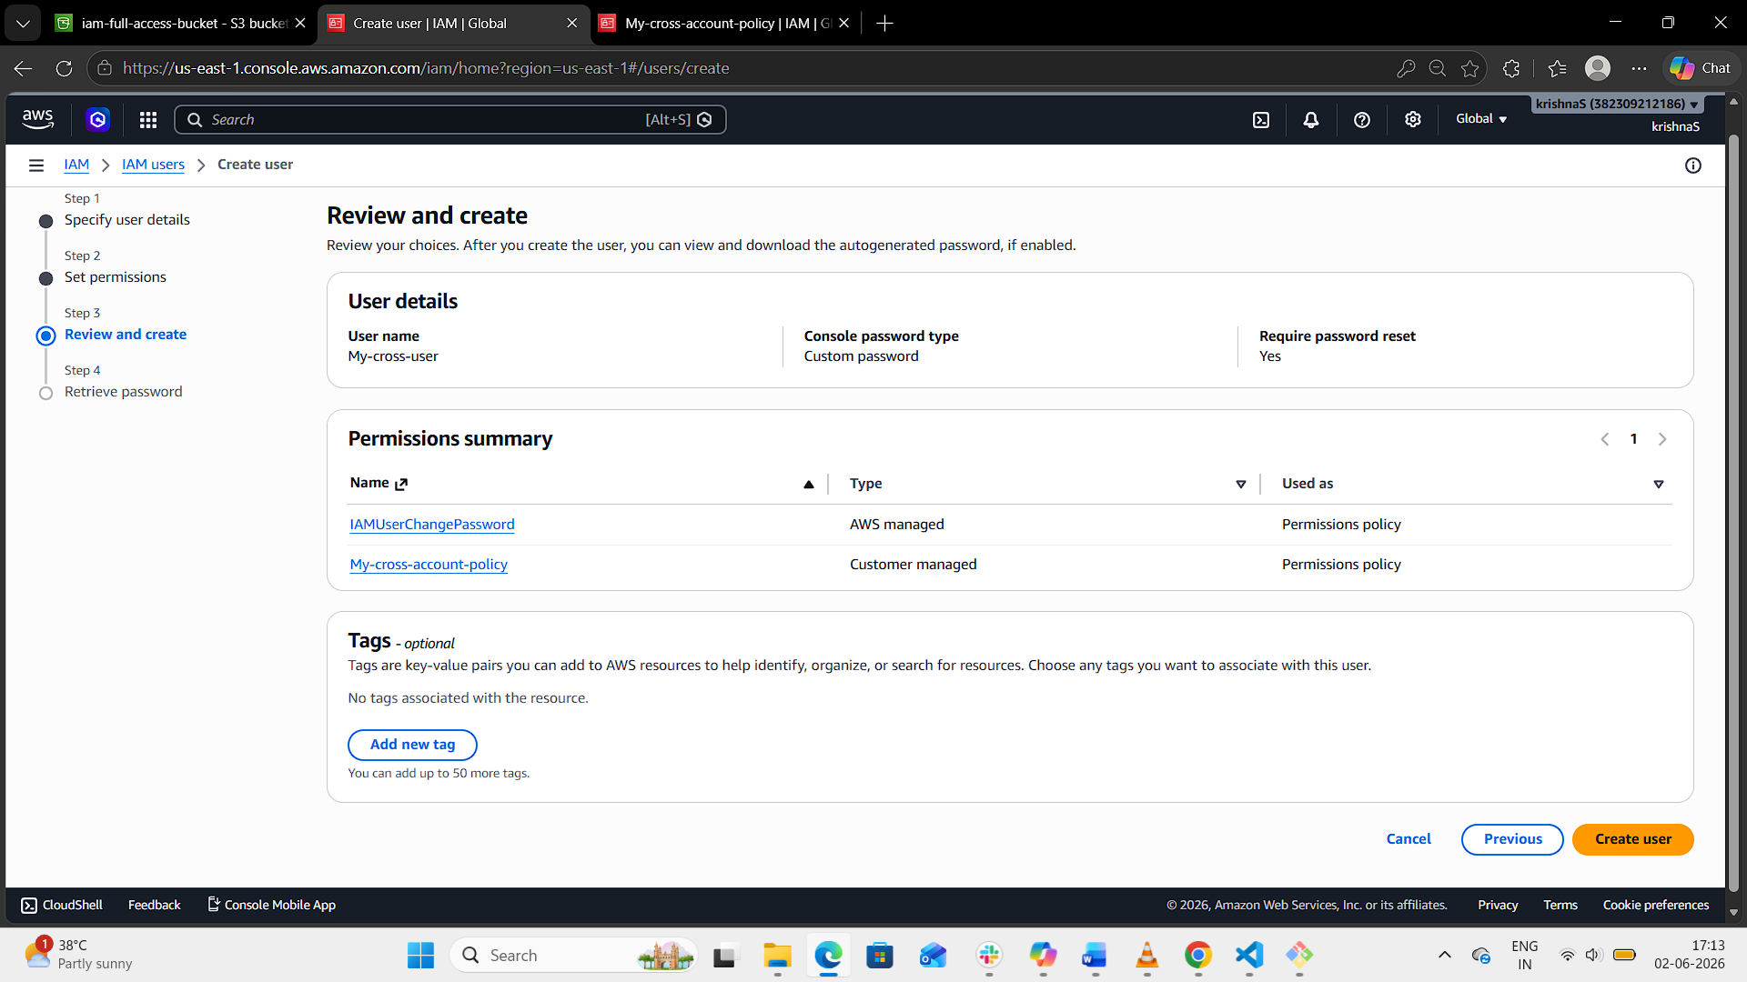

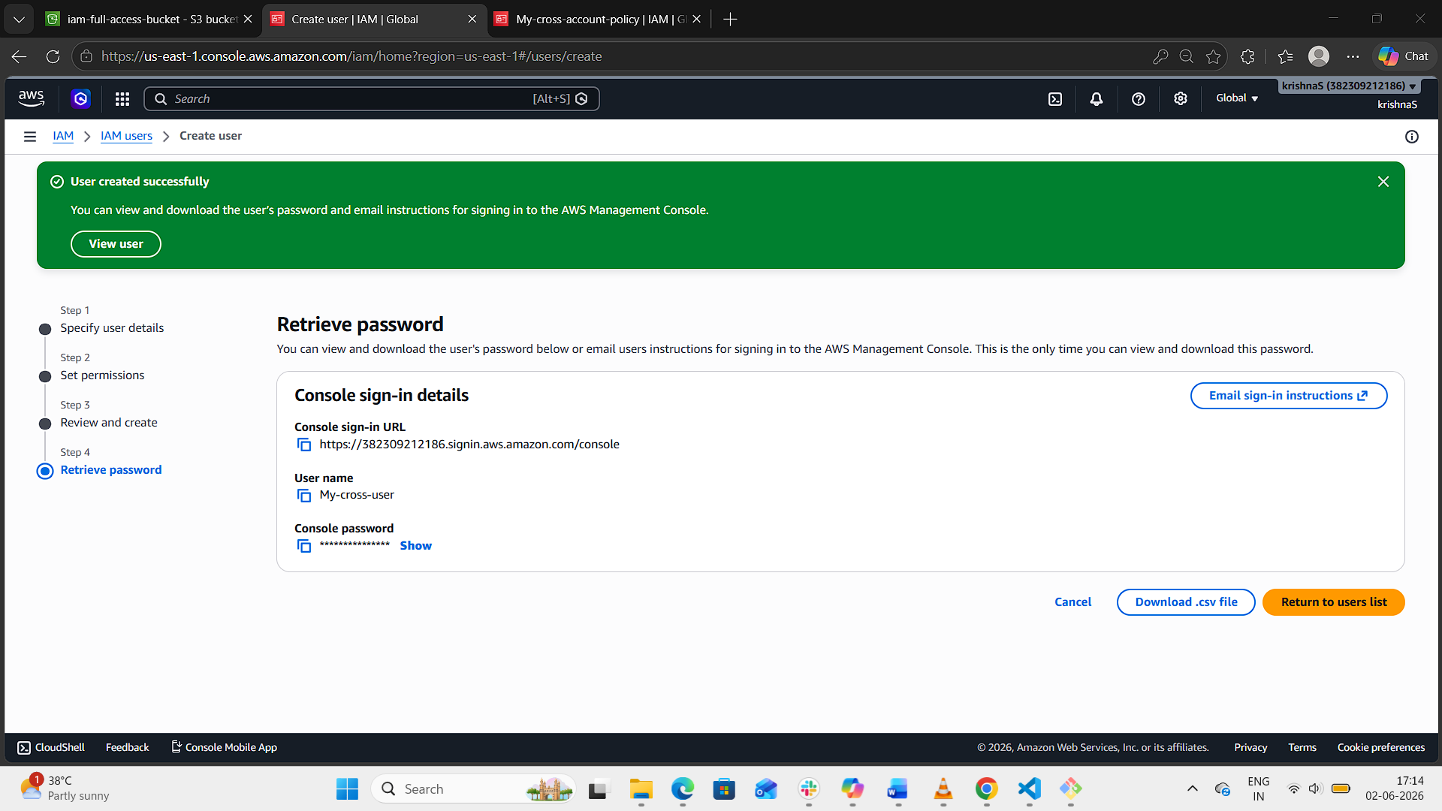
Step 2: Add Bucket Policy in Account B
On the S3 bucket in Account B, add a bucket policy that trusts Account A’s user:
json
{
"Version": "2012-10-17",
"Statement": [
{
"Sid": "AllowAccountAUserAccess",
"Effect": "Allow",
"Principal": {
"AWS": "arn:aws:iam:: 382309212186:user/My-cross-user"
},
"Action": [
"s3:GetObject",
"s3:ListBucket"
],
"Resource": [
"arn:aws:s3:::test05868",
"arn:aws:s3:::test05868/*"
]
}
]
}
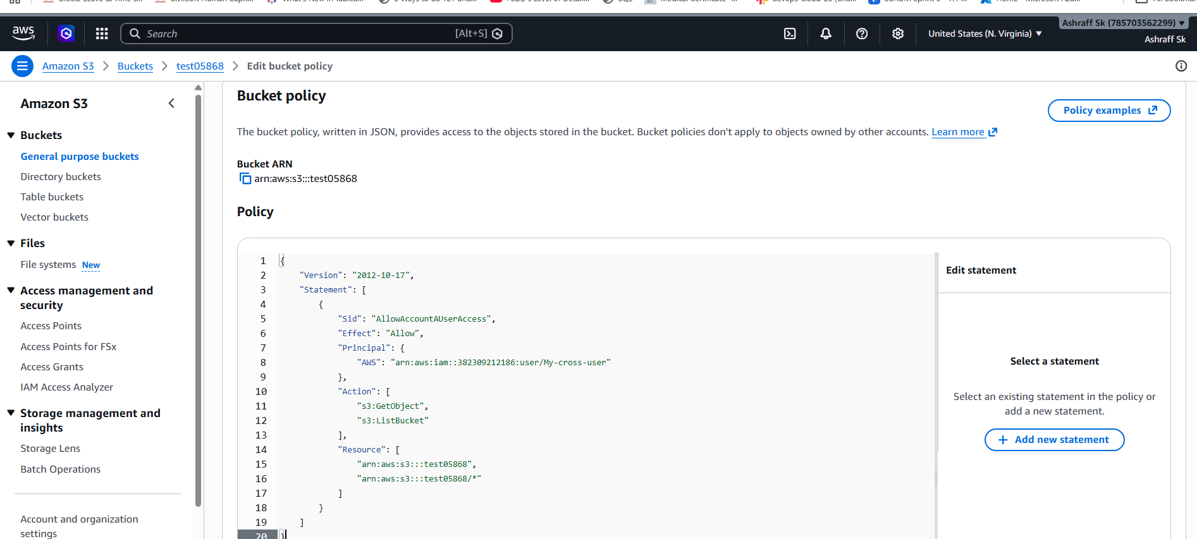
Step 3: Test Access
From Account A’s user session, run:
bash
aws s3 ls s3://bucket-in-account-b
aws s3 cp s3://bucket-in-account-b/object.txt .
If configured correctly, the user should be able to list and download object
